

Department of Software Engineering

**SOFTWARE DESIGN ARCHITECTURE (LAB)**

**Student Management System**

**Group Members**

|  |  |
| --- | --- |
| **Uzair Mehmood** | **51739** |
| **Hammad Shaikh**  **Noman Ali Siddique** | **51717**  **51777** |
|  |  |
|  |  |

**BSE-6A**

**Spring 2020**

**Submitted to**

**Engr. Muhammad Rehan Baig**

Table of Contents

1

Department of Software Engineering 1

1. ABSTRACT 7

2. INTRODUCTION 8

3. Scope 9

4. Code 9

4.1. Properties 9

4.1.1. AssemblyInfo.cs 9

4.2. App_Start 10

4.2.1. BuildConfig.cs 10

4.2.2. FilterConfig.cs 10

4.2.3. IdentityCongig.cs 11

4.2.4. RouteConfig.cs 13

4.2.5. Startup.Auth.cs 13

4.3. Controller 15

4.3.1. AccountController.cs 15

4.3.2. BatchController.cs 32

4.3.3. CourseController.cs 34

4.3.4. HomeController.cs 36

4.3.5. LoginController.cs 37

4.3.6. ManageController.cs 38

4.3.7. RegistrationController.cs 52

4.3.8. UserController.cs 54

4.4. Model 57

4.5. AccountViewModel.cs 57

4.6. IdentityModel.cs 59

4.7. ManageViewModel.cs 59

4.8. Model.edmx 62

4.9. Views: 62

4.10. Account: 62

4.10.1. ExternalLogins 62

4.10.2. ConfirmEmail 63

4.10.3. ExternalLoginConfirmation 63

4.10.4. ExternalLoginFailure 64

4.10.5. ForgotPassword 64

4.10.6. ForgotPasswordConfirmation 65

4.10.7. Login 65

4.10.8. Register 67

4.10.9. ResetPassword 67

4.10.10. ResetPasswordConfirmation 68

4.10.11. SendCode 68

4.10.12. VerifyCode 69

4.11. Batch 70

4.11.1. Create 70

4.11.2. Delete 71

4.11.3. Details 71

4.11.4. Edit 72

4.11.5. Index 73

4.12. Course 74

4.12.1. Create 74

4.12.2. Delete 75

4.12.3. Details 75

4.12.4. Edit 76

4.12.5. Index 77

5. Home 78

5.1.1. About 78

5.1.2. Contact 78

5.1.3. Index 78

5.2. Login 79

5.2.1. Index.cs.html 79

6. Manage 80

6.1.1. AddPhoneNumber 80

6.1.2. ChangePassword 81

6.1.3. Index.cs.html 82

6.1.4. ManageLogins.cshtml 83

6.1.5. SetPassword.cshtml 85

6.1.6. VerifyPhoneNumber.cshtml 86

6.2. Registration: 86

6.2.1. Create 86

6.2.2. Delete 88

6.2.3. Details 89

6.2.4. Edit 90

6.2.5. Index 92

6.3. Shared 93

6.3.1. Layout.cshtml 93

6.3.2. LoginPartial.cshtml 94

6.3.3. Error.cshtml 95

6.3.4. Lockout.cs.html 95

6.4. User 95

6.4.1. Create 95

6.4.2. Delete 96

6.4.3. Details 97

6.4.4. Edit 98

6.4.5. Index 99

7. Output 101

7.1. Course 101

7.1.1. Course Details 101

7.1.2. Add Course 101

7.1.3. View Course 102

7.1.4. Edit Course 102

7.1.5. Delete Course 102

7.2. Batch: 103

7.2.1. Batch Details 103

7.2.2. Add Batch 103

7.2.3. View Batch 104

7.2.4. Edit Batch 104

7.2.5. Delete Batch 105

7.3. Registration: 105

7.4. User: 106

7.4.1. User Details 106

7.4.2. Add User 106

7.4.3. View User 107

7.4.4. Edit User 107

7.4.5. Delete User 108

7.5. Login 108

7.5.1. Login View 108

7.5.2. Error 109

7.6. Display User Name 109

8. Database 110

8.1. Table-Design 110

8.1.1. Batch 110

8.1.2. Course 110

8.1.3. Registration 110

8.1.4. User 111

8.2. Data In Tables 111

8.2.1. Batch 111

8.2.2. Course 111

8.2.3. Registration 112

8.2.4. User 112

9. Solution Expolrer 113

10. Conclusion 116

# ABSTRACT

Students form a main part of any institution that concerns with. But the institutions find it difficult to keep details of so many students of the organization just in one stretch. It will involve a lot of pen paper work. Sometimes there will be some huge heap of files bundled up and kept together in some corner of the office. If you want any information regarding the particular student then it can be obtained by just entering the roll number or the name of the student to be searched. This student management system will make the work of storing the data in an organized way.

The student management system application will help in managing the student’s reports, results and exams will become easier with one such system. It will also help in saving time and effort. The user interface must be user friendly and easy to understand. The information of the particular student will be obtained in just one mouse click. Some of the features that it can include are as follows:

Student database management: The details of the students of the organizations can be stored in the database with the use this application.

Results: The results of the students can also be accessed and stored through this application.

Security: The data that will be disclosed will be more secure since there will be no access to the unknown users.

Performance: The performance of the students might be in curriculum as well as co-curriculum can also be stored through the use of this application.

One-click access: You will obtain the details of the students by entering his/her name or the roll number just in one click.

User interface: The user interface must be simple and easy to understand.

Personal details: All the personal details of the students can be obtained in just one mouse click.

# INTRODUCTION

Student management system is an environment where all the process of the student in the institution is managed. It is done through the automated computerized method. Conventionally this system is done using papers, file and binders.

This system saves the time of the student and of the administrator. It includes process like registration of the student’s details, assigning the department based on their course and maintenance of the record.

This system reduces the cost and workforce required for this job. As the system is online the information is globally present to everyone. This makes the system easy to handle and feasible for finding the omission with updating at the same time.

As for the existing system, they use to maintain their record manually which makes it vulnerable to security. If filed a query to search or update in a manual system, it will take a lot of time to process the query and make a report which is a tedious job.

As the system used in the institute is outdated as it requires paper, files and the binders, which will require the human workforce to maintain them. To get registered in the institute, a student in this system one should come to the university.

Get the forms from the counter while standing in the queue which consumes a lot of the student’s time as well as of management team. As the number of the student increases in the institute manually managing the strength becomes a hectic job for the administrator.

This computerized system store all the data in the database which makes it easy to fetch and update whenever needed.

# Scope

The scope of this project is limited to the design and implementation of a Student Information Management System. The purpose of the Student Information Management system is to allow for storing information of large number of students. Different privileges are given to different types of users. The Student Information Management System will make use of Visual Basic 6.0 as its front end and Microsoft Access as its back end.

# Code

## Properties

### AssemblyInfo.cs

using System.Reflection;

using System.Runtime.CompilerServices;

using System.Runtime.InteropServices;

// General Information about an assembly is controlled through the following

// set of attributes. Change these attribute values to modify the information

// associated with an assembly.

[assembly: AssemblyTitle("Student_Management_System")]

[assembly: AssemblyDescription("")]

[assembly: AssemblyConfiguration("")]

[assembly: AssemblyCompany("")]

[assembly: AssemblyProduct("Student_Management_System")]

[assembly: AssemblyCopyright("Copyright © 2020")]

[assembly: AssemblyTrademark("")]

[assembly: AssemblyCulture("")]

// Setting ComVisible to false makes the types in this assembly not visible

// to COM components. If you need to access a type in this assembly from

// COM, set the ComVisible attribute to true on that type.

[assembly: ComVisible(false)]

// The following GUID is for the ID of the typelib if this project is exposed to COM

[assembly: Guid("987e33ff-db5f-42a4-b70c-0b36d39f9174")]

// Version information for an assembly consists of the following four values:

//

// Major Version

// Minor Version

// Build Number

// Revision

//

// You can specify all the values or you can default the Revision and Build Numbers

// by using the '*' as shown below:

[assembly: AssemblyVersion("1.0.0.0")]

[assembly: AssemblyFileVersion("1.0.0.0")]

## App_Start

### BuildConfig.cs

using System.Web;

using System.Web.Optimization;

namespace Student_Management_System

{

public class BundleConfig

{

// For more information on bundling, visit http://go.microsoft.com/fwlink/?LinkId=301862

public static void RegisterBundles(BundleCollection bundles)

{

bundles.Add(new ScriptBundle("~/bundles/jquery").Include(

"~/Scripts/jquery-{version}.js"));

bundles.Add(new ScriptBundle("~/bundles/jqueryval").Include(

"~/Scripts/jquery.validate*"));

// Use the development version of Modernizr to develop with and learn from. Then, when you're

// ready for production, use the build tool at http://modernizr.com to pick only the tests you need.

bundles.Add(new ScriptBundle("~/bundles/modernizr").Include(

"~/Scripts/modernizr-*"));

bundles.Add(new ScriptBundle("~/bundles/bootstrap").Include(

"~/Scripts/bootstrap.js",

"~/Scripts/respond.js"));

bundles.Add(new StyleBundle("~/Content/css").Include(

"~/Content/bootstrap.css",

"~/Content/site.css"));

}

}

}

### FilterConfig.cs

using System.Web;

using System.Web.Mvc;

namespace Student_Management_System

{

public class FilterConfig

{

public static void RegisterGlobalFilters(GlobalFilterCollection filters)

{

filters.Add(new HandleErrorAttribute());

}

}

}

### IdentityCongig.cs

using System;

using System.Collections.Generic;

using System.Data.Entity;

using System.Linq;

using System.Security.Claims;

using System.Threading.Tasks;

using System.Web;

using Microsoft.AspNet.Identity;

using Microsoft.AspNet.Identity.EntityFramework;

using Microsoft.AspNet.Identity.Owin;

using Microsoft.Owin;

using Microsoft.Owin.Security;

using Student_Management_System.Models;

namespace Student_Management_System

{

public class EmailService : IIdentityMessageService

{

public Task SendAsync(IdentityMessage message)

{

// Plug in your email service here to send an email.

return Task.FromResult(0);

}

}

public class SmsService : IIdentityMessageService

{

public Task SendAsync(IdentityMessage message)

{

// Plug in your SMS service here to send a text message.

return Task.FromResult(0);

}

}

// Configure the application user manager used in this application. UserManager is defined in ASP.NET Identity and is used by the application.

public class ApplicationUserManager : UserManager<ApplicationUser>

{

public ApplicationUserManager(IUserStore<ApplicationUser> store)

: base(store)

{

}

public static ApplicationUserManager Create(IdentityFactoryOptions<ApplicationUserManager> options, IOwinContext context)

{

var manager = new ApplicationUserManager(new UserStore<ApplicationUser>(context.Get<ApplicationDbContext>()));

// Configure validation logic for usernames

manager.UserValidator = new UserValidator<ApplicationUser>(manager)

{

AllowOnlyAlphanumericUserNames = false,

RequireUniqueEmail = true

};

// Configure validation logic for passwords

manager.PasswordValidator = new PasswordValidator

{

RequiredLength = 6,

RequireNonLetterOrDigit = true,

RequireDigit = true,

RequireLowercase = true,

RequireUppercase = true,

};

// Configure user lockout defaults

manager.UserLockoutEnabledByDefault = true;

manager.DefaultAccountLockoutTimeSpan = TimeSpan.FromMinutes(5);

manager.MaxFailedAccessAttemptsBeforeLockout = 5;

// Register two factor authentication providers. This application uses Phone and Emails as a step of receiving a code for verifying the user

// You can write your own provider and plug it in here.

manager.RegisterTwoFactorProvider("Phone Code", new PhoneNumberTokenProvider<ApplicationUser>

{

MessageFormat = "Your security code is {0}"

});

manager.RegisterTwoFactorProvider("Email Code", new EmailTokenProvider<ApplicationUser>

{

Subject = "Security Code",

BodyFormat = "Your security code is {0}"

});

manager.EmailService = new EmailService();

manager.SmsService = new SmsService();

var dataProtectionProvider = options.DataProtectionProvider;

if (dataProtectionProvider != null)

{

manager.UserTokenProvider =

new DataProtectorTokenProvider<ApplicationUser>(dataProtectionProvider.Create("ASP.NET Identity"));

}

return manager;

}

}

// Configure the application sign-in manager which is used in this application.

public class ApplicationSignInManager : SignInManager<ApplicationUser, string>

{

public ApplicationSignInManager(ApplicationUserManager userManager, IAuthenticationManager authenticationManager)

: base(userManager, authenticationManager)

{

}

public override Task<ClaimsIdentity> CreateUserIdentityAsync(ApplicationUser user)

{

return user.GenerateUserIdentityAsync((ApplicationUserManager)UserManager);

}

public static ApplicationSignInManager Create(IdentityFactoryOptions<ApplicationSignInManager> options, IOwinContext context)

{

return new ApplicationSignInManager(context.GetUserManager<ApplicationUserManager>(), context.Authentication);

}

}

}

### RouteConfig.cs

using System;

using System.Collections.Generic;

using System.Linq;

using System.Web;

using System.Web.Mvc;

using System.Web.Routing;

namespace Student_Management_System

{

public class RouteConfig

{

public static void RegisterRoutes(RouteCollection routes)

{

routes.IgnoreRoute("{resource}.axd/{*pathInfo}");

routes.MapRoute(

name: "Default",

url: "{controller}/{action}/{id}",

defaults: new { controller = "Course", action = "Index", id = UrlParameter.Optional }

);

}

}

}

### Startup.Auth.cs

using System;

using Microsoft.AspNet.Identity;

using Microsoft.AspNet.Identity.Owin;

using Microsoft.Owin;

using Microsoft.Owin.Security.Cookies;

using Microsoft.Owin.Security.Google;

using Owin;

using Student_Management_System.Models;

namespace Student_Management_System

{

public partial class Startup

{

// For more information on configuring authentication, please visit http://go.microsoft.com/fwlink/?LinkId=301864

public void ConfigureAuth(IAppBuilder app)

{

// Configure the db context, user manager and signin manager to use a single instance per request

app.CreatePerOwinContext(ApplicationDbContext.Create);

app.CreatePerOwinContext<ApplicationUserManager>(ApplicationUserManager.Create);

app.CreatePerOwinContext<ApplicationSignInManager>(ApplicationSignInManager.Create);

// Enable the application to use a cookie to store information for the signed in user

// and to use a cookie to temporarily store information about a user logging in with a third party login provider

// Configure the sign in cookie

app.UseCookieAuthentication(new CookieAuthenticationOptions

{

AuthenticationType = DefaultAuthenticationTypes.ApplicationCookie,

LoginPath = new PathString("/Account/Login"),

Provider = new CookieAuthenticationProvider

{

// Enables the application to validate the security stamp when the user logs in.

// This is a security feature which is used when you change a password or add an external login to your account.

OnValidateIdentity = SecurityStampValidator.OnValidateIdentity<ApplicationUserManager, ApplicationUser>(

validateInterval: TimeSpan.FromMinutes(30),

regenerateIdentity: (manager, user) => user.GenerateUserIdentityAsync(manager))

}

});

app.UseExternalSignInCookie(DefaultAuthenticationTypes.ExternalCookie);

// Enables the application to temporarily store user information when they are verifying the second factor in the two-factor authentication process.

app.UseTwoFactorSignInCookie(DefaultAuthenticationTypes.TwoFactorCookie, TimeSpan.FromMinutes(5));

// Enables the application to remember the second login verification factor such as phone or email.

// Once you check this option, your second step of verification during the login process will be remembered on the device where you logged in from.

// This is similar to the RememberMe option when you log in.

app.UseTwoFactorRememberBrowserCookie(DefaultAuthenticationTypes.TwoFactorRememberBrowserCookie);

// Uncomment the following lines to enable logging in with third party login providers

//app.UseMicrosoftAccountAuthentication(

// clientId: "",

// clientSecret: "");

//app.UseTwitterAuthentication(

// consumerKey: "",

// consumerSecret: "");

//app.UseFacebookAuthentication(

// appId: "",

// appSecret: "");

//app.UseGoogleAuthentication(new GoogleOAuth2AuthenticationOptions()

//{

// ClientId = "",

// ClientSecret = ""

//});

}

}

}

## Controller

### AccountController.cs

using System;

using System.Globalization;

using System.Linq;

using System.Security.Claims;

using System.Threading.Tasks;

using System.Web;

using System.Web.Mvc;

using Microsoft.AspNet.Identity;

using Microsoft.AspNet.Identity.Owin;

using Microsoft.Owin.Security;

using Student_Management_System.Models;

namespace Student_Management_System.Controllers

{

[Authorize]

public class AccountController : Controller

{

private ApplicationSignInManager _signInManager;

private ApplicationUserManager _userManager;

public AccountController()

{

}

public AccountController(ApplicationUserManager userManager, ApplicationSignInManager signInManager )

{

UserManager = userManager;

SignInManager = signInManager;

}

public ApplicationSignInManager SignInManager

{

get

{

return _signInManager ?? HttpContext.GetOwinContext().Get<ApplicationSignInManager>();

}

private set

{

_signInManager = value;

}

}

public ApplicationUserManager UserManager

{

get

{

return _userManager ?? HttpContext.GetOwinContext().GetUserManager<ApplicationUserManager>();

}

private set

{

_userManager = value;

}

}

//

// GET: /Account/Login

[AllowAnonymous]

public ActionResult Login(string returnUrl)

{

ViewBag.ReturnUrl = returnUrl;

return View();

}

//

// POST: /Account/Login

[HttpPost]

[AllowAnonymous]

[ValidateAntiForgeryToken]

public async Task<ActionResult> Login(LoginViewModel model, string returnUrl)

{

if (!ModelState.IsValid)

{

return View(model);

}

// This doesn't count login failures towards account lockout

// To enable password failures to trigger account lockout, change to shouldLockout: true

var result = await SignInManager.PasswordSignInAsync(model.Email, model.Password, model.RememberMe, shouldLockout: false);

switch (result)

{

case SignInStatus.Success:

return RedirectToLocal(returnUrl);

case SignInStatus.LockedOut:

return View("Lockout");

case SignInStatus.RequiresVerification:

return RedirectToAction("SendCode", new { ReturnUrl = returnUrl, RememberMe = model.RememberMe });

case SignInStatus.Failure:

default:

ModelState.AddModelError("", "Invalid login attempt.");

return View(model);

}

}

//

// GET: /Account/VerifyCode

[AllowAnonymous]

public async Task<ActionResult> VerifyCode(string provider, string returnUrl, bool rememberMe)

{

// Require that the user has already logged in via username/password or external login

if (!await SignInManager.HasBeenVerifiedAsync())

{

return View("Error");

}

return View(new VerifyCodeViewModel { Provider = provider, ReturnUrl = returnUrl, RememberMe = rememberMe });

}

//

// POST: /Account/VerifyCode

[HttpPost]

[AllowAnonymous]

[ValidateAntiForgeryToken]

public async Task<ActionResult> VerifyCode(VerifyCodeViewModel model)

{

if (!ModelState.IsValid)

{

return View(model);

}

// The following code protects for brute force attacks against the two factor codes.

// If a user enters incorrect codes for a specified amount of time then the user account

// will be locked out for a specified amount of time.

// You can configure the account lockout settings in IdentityConfig

var result = await SignInManager.TwoFactorSignInAsync(model.Provider, model.Code, isPersistent: model.RememberMe, rememberBrowser: model.RememberBrowser);

switch (result)

{

case SignInStatus.Success:

return RedirectToLocal(model.ReturnUrl);

case SignInStatus.LockedOut:

return View("Lockout");

case SignInStatus.Failure:

default:

ModelState.AddModelError("", "Invalid code.");

return View(model);

}

}

//

// GET: /Account/Register

[AllowAnonymous]

public ActionResult Register()

{

return View();

}

//

// POST: /Account/Register

[HttpPost]

[AllowAnonymous]

[ValidateAntiForgeryToken]

public async Task<ActionResult> Register(RegisterViewModel model)

{

if (ModelState.IsValid)

{

var user = new ApplicationUser { UserName = model.Email, Email = model.Email };

var result = await UserManager.CreateAsync(user, model.Password);

if (result.Succeeded)

{

await SignInManager.SignInAsync(user, isPersistent:false, rememberBrowser:false);

// For more information on how to enable account confirmation and password reset please visit http://go.microsoft.com/fwlink/?LinkID=320771

// Send an email with this link

// string code = await UserManager.GenerateEmailConfirmationTokenAsync(user.Id);

// var callbackUrl = Url.Action("ConfirmEmail", "Account", new { userId = user.Id, code = code }, protocol: Request.Url.Scheme);

// await UserManager.SendEmailAsync(user.Id, "Confirm your account", "Please confirm your account by clicking <a href=\"" + callbackUrl + "\">here</a>");

return RedirectToAction("Index", "Home");

}

AddErrors(result);

}

// If we got this far, something failed, redisplay form

return View(model);

}

//

// GET: /Account/ConfirmEmail

[AllowAnonymous]

public async Task<ActionResult> ConfirmEmail(string userId, string code)

{

if (userId == null || code == null)

{

return View("Error");

}

var result = await UserManager.ConfirmEmailAsync(userId, code);

return View(result.Succeeded ? "ConfirmEmail" : "Error");

}

//

// GET: /Account/ForgotPassword

[AllowAnonymous]

public ActionResult ForgotPassword()

{

return View();

}

//

// POST: /Account/ForgotPassword

[HttpPost]

[AllowAnonymous]

[ValidateAntiForgeryToken]

public async Task<ActionResult> ForgotPassword(ForgotPasswordViewModel model)

{

if (ModelState.IsValid)

{

var user = await UserManager.FindByNameAsync(model.Email);

if (user == null || !(await UserManager.IsEmailConfirmedAsync(user.Id)))

{

// Don't reveal that the user does not exist or is not confirmed

return View("ForgotPasswordConfirmation");

}

// For more information on how to enable account confirmation and password reset please visit http://go.microsoft.com/fwlink/?LinkID=320771

// Send an email with this link

// string code = await UserManager.GeneratePasswordResetTokenAsync(user.Id);

// var callbackUrl = Url.Action("ResetPassword", "Account", new { userId = user.Id, code = code }, protocol: Request.Url.Scheme);

// await UserManager.SendEmailAsync(user.Id, "Reset Password", "Please reset your password by clicking <a href=\"" + callbackUrl + "\">here</a>");

// return RedirectToAction("ForgotPasswordConfirmation", "Account");

}

// If we got this far, something failed, redisplay form

return View(model);

}

//

// GET: /Account/ForgotPasswordConfirmation

[AllowAnonymous]

public ActionResult ForgotPasswordConfirmation()

{

return View();

}

//

// GET: /Account/ResetPassword

[AllowAnonymous]

public ActionResult ResetPassword(string code)

{

return code == null ? View("Error") : View();

}

//

// POST: /Account/ResetPassword

[HttpPost]

[AllowAnonymous]

[ValidateAntiForgeryToken]

public async Task<ActionResult> ResetPassword(ResetPasswordViewModel model)

{

if (!ModelState.IsValid)

{

return View(model);

}

var user = await UserManager.FindByNameAsync(model.Email);

if (user == null)

{

// Don't reveal that the user does not exist

return RedirectToAction("ResetPasswordConfirmation", "Account");

}

var result = await UserManager.ResetPasswordAsync(user.Id, model.Code, model.Password);

if (result.Succeeded)

{

return RedirectToAction("ResetPasswordConfirmation", "Account");

}

AddErrors(result);

return View();

}

//

// GET: /Account/ResetPasswordConfirmation

[AllowAnonymous]

public ActionResult ResetPasswordConfirmation()

{

return View();

}

//

// POST: /Account/ExternalLogin

[HttpPost]

[AllowAnonymous]

[ValidateAntiForgeryToken]

public ActionResult ExternalLogin(string provider, string returnUrl)

{

// Request a redirect to the external login provider

return new ChallengeResult(provider, Url.Action("ExternalLoginCallback", "Account", new { ReturnUrl = returnUrl }));

}

//

// GET: /Account/SendCode

[AllowAnonymous]

public async Task<ActionResult> SendCode(string returnUrl, bool rememberMe)

{

var userId = await SignInManager.GetVerifiedUserIdAsync();

if (userId == null)

{

return View("Error");

}

var userFactors = await UserManager.GetValidTwoFactorProvidersAsync(userId);

var factorOptions = userFactors.Select(purpose => new SelectListItem { Text = purpose, Value = purpose }).ToList();

return View(new SendCodeViewModel { Providers = factorOptions, ReturnUrl = returnUrl, RememberMe = rememberMe });

}

//

// POST: /Account/SendCode

[HttpPost]

[AllowAnonymous]

[ValidateAntiForgeryToken]

public async Task<ActionResult> SendCode(SendCodeViewModel model)

{

if (!ModelState.IsValid)

{

return View();

}

// Generate the token and send it

if (!await SignInManager.SendTwoFactorCodeAsync(model.SelectedProvider))

{

return View("Error");

}

return RedirectToAction("VerifyCode", new { Provider = model.SelectedProvider, ReturnUrl = model.ReturnUrl, RememberMe = model.RememberMe });

}

//

// GET: /Account/ExternalLoginCallback

[AllowAnonymous]

public async Task<ActionResult> ExternalLoginCallback(string returnUrl)

{

var loginInfo = await AuthenticationManager.GetExternalLoginInfoAsync();

if (loginInfo == null)

{

return RedirectToAction("Login");

}

// Sign in the user with this external login provider if the user already has a login

var result = await SignInManager.ExternalSignInAsync(loginInfo, isPersistent: false);

switch (result)

{

case SignInStatus.Success:

return RedirectToLocal(returnUrl);

case SignInStatus.LockedOut:

return View("Lockout");

case SignInStatus.RequiresVerification:

return RedirectToAction("SendCode", new { ReturnUrl = returnUrl, RememberMe = false });

case SignInStatus.Failure:

default:

// If the user does not have an account, then prompt the user to create an account

ViewBag.ReturnUrl = returnUrl;

ViewBag.LoginProvider = loginInfo.Login.LoginProvider;

return View("ExternalLoginConfirmation", new ExternalLoginConfirmationViewModel { Email = loginInfo.Email });

}

}

//

// POST: /Account/ExternalLoginConfirmation

[HttpPost]

[AllowAnonymous]

[ValidateAntiForgeryToken]

public async Task<ActionResult> ExternalLoginConfirmation(ExternalLoginConfirmationViewModel model, string returnUrl)

{

if (User.Identity.IsAuthenticated)

{

return RedirectToAction("Index", "Manage");

}

if (ModelState.IsValid)

{

// Get the information about the user from the external login provider

var info = await AuthenticationManager.GetExternalLoginInfoAsync();

if (info == null)

{

return View("ExternalLoginFailure");

}

var user = new ApplicationUser { UserName = model.Email, Email = model.Email };

var result = await UserManager.CreateAsync(user);

if (result.Succeeded)

{

result = await UserManager.AddLoginAsync(user.Id, info.Login);

if (result.Succeeded)

{

await SignInManager.SignInAsync(user, isPersistent: false, rememberBrowser: false);

return RedirectToLocal(returnUrl);

}

}

AddErrors(result);

}

ViewBag.ReturnUrl = returnUrl;

return View(model);

}

//

// POST: /Account/LogOff

[HttpPost]

[ValidateAntiForgeryToken]

public ActionResult LogOff()

{

AuthenticationManager.SignOut(DefaultAuthenticationTypes.ApplicationCookie);

return RedirectToAction("Index", "Home");

}

//

// GET: /Account/ExternalLoginFailure

[AllowAnonymous]

public ActionResult ExternalLoginFailure()

{

return View();

}

protected override void Dispose(bool disposing)

{

if (disposing)

{

if (_userManager != null)

{

_userManager.Dispose();

_userManager = null;

}

if (_signInManager != null)

{

_signInManager.Dispose();

_signInManager = null;

}

}

base.Dispose(disposing);

}

#region Helpers

// Used for XSRF protection when adding external logins

private const string XsrfKey = "XsrfId";

private IAuthenticationManager AuthenticationManager

{

get

{

return HttpContext.GetOwinContext().Authentication;

}

}

private void AddErrors(IdentityResult result)

{

foreach (var error in result.Errors)

{

ModelState.AddModelError("", error);

}

}

private ActionResult RedirectToLocal(string returnUrl)

{

if (Url.IsLocalUrl(returnUrl))

{

return Redirect(returnUrl);

}

return RedirectToAction("Index", "Home");

}

internal class ChallengeResult : HttpUnauthorizedResult

{

public ChallengeResult(string provider, string redirectUri)

: this(provider, redirectUri, null)

{

}

public ChallengeResult(string provider, string redirectUri, string userId)

{

LoginProvider = provider;

RedirectUri = redirectUri;

UserId = userId;

}

public string LoginProvider { get; set; }

public string RedirectUri { get; set; }

public string UserId { get; set; }

public override void ExecuteResult(ControllerContext context)

{

var properties = new AuthenticationProperties { RedirectUri = RedirectUri };

if (UserId != null)

{

properties.Dictionary[XsrfKey] = UserId;

}

context.HttpContext.GetOwinContext().Authentication.Challenge(properties, LoginProvider);

}

}

#endregion

}

}

### BatchController.cs

/using System;

using System.Collections.Generic;

using System.Data;

using System.Data.Entity;

using System.Linq;

using System.Net;

using System.Web;

using System.Web.Mvc;

using Student_Management_System.Models;

namespace Student_Management_System.Controllers

{

public class BatchController : Controller

{

private StudentEntities db = new StudentEntities();

// GET: Batch

public ActionResult Index()

{

return View(db.batches.ToList());

}

// GET: Batch/Details/5

public ActionResult Details(int? id)

{

if (id == null)

{

return new HttpStatusCodeResult(HttpStatusCode.BadRequest);

}

batch batch = db.batches.Find(id);

if (batch == null)

{

return HttpNotFound();

}

return View(batch);

}

// GET: Batch/Create

public ActionResult Create()

{

return View();

}

// POST: Batch/Create

// To protect from overposting attacks, please enable the specific properties you want to bind to, for

// more details see http://go.microsoft.com/fwlink/?LinkId=317598.

[HttpPost]

[ValidateAntiForgeryToken]

public ActionResult Create([Bind(Include = "id,batch1,year")] batch batch)

{

if (ModelState.IsValid)

{

db.batches.Add(batch);

db.SaveChanges();

return RedirectToAction("Index");

}

return View(batch);

}

// GET: Batch/Edit/5

public ActionResult Edit(int? id)

{

if (id == null)

{

return new HttpStatusCodeResult(HttpStatusCode.BadRequest);

}

batch batch = db.batches.Find(id);

if (batch == null)

{

return HttpNotFound();

}

return View(batch);

}

// POST: Batch/Edit/5

// To protect from overposting attacks, please enable the specific properties you want to bind to, for

// more details see http://go.microsoft.com/fwlink/?LinkId=317598.

[HttpPost]

[ValidateAntiForgeryToken]

public ActionResult Edit([Bind(Include = "id,batch1,year")] batch batch)

{

if (ModelState.IsValid)

{

db.Entry(batch).State = EntityState.Modified;

db.SaveChanges();

return RedirectToAction("Index");

}

return View(batch);

}

// GET: Batch/Delete/5

public ActionResult Delete(int? id)

{

if (id == null)

{

return new HttpStatusCodeResult(HttpStatusCode.BadRequest);

}

batch batch = db.batches.Find(id);

if (batch == null)

{

return HttpNotFound();

}

return View(batch);

}

// POST: Batch/Delete/5

[HttpPost, ActionName("Delete")]

[ValidateAntiForgeryToken]

public ActionResult DeleteConfirmed(int id)

{

batch batch = db.batches.Find(id);

db.batches.Remove(batch);

db.SaveChanges();

return RedirectToAction("Index");

}

protected override void Dispose(bool disposing)

{

if (disposing)

{

db.Dispose();

}

base.Dispose(disposing);

}

}

}

### CourseController.cs

/using System;

using System.Collections.Generic;

using System.Data;

using System.Data.Entity;

using System.Linq;

using System.Net;

using System.Web;

using System.Web.Mvc;

using Student_Management_System.Models;

namespace Student_Management_System.Controllers

{

public class CourseController : Controller

{

private StudentEntities db = new StudentEntities();

// GET: Course

public ActionResult Index()

{

return View(db.courses.ToList());

}

// GET: Course/Details/5

public ActionResult Details(int? id)

{

if (id == null)

{

return new HttpStatusCodeResult(HttpStatusCode.BadRequest);

}

course course = db.courses.Find(id);

if (course == null)

{

return HttpNotFound();

}

return View(course);

}

// GET: Course/Create

public ActionResult Create()

{

return View();

}

// POST: Course/Create

// To protect from overposting attacks, please enable the specific properties you want to bind to, for

// more details see http://go.microsoft.com/fwlink/?LinkId=317598.

[HttpPost]

[ValidateAntiForgeryToken]

public ActionResult Create([Bind(Include = "id,course1,duration")] course course)

{

if (ModelState.IsValid)

{

db.courses.Add(course);

db.SaveChanges();

return RedirectToAction("Index");

}

return View(course);

}

// GET: Course/Edit/5

public ActionResult Edit(int? id)

{

if (id == null)

{

return new HttpStatusCodeResult(HttpStatusCode.BadRequest);

}

course course = db.courses.Find(id);

if (course == null)

{

return HttpNotFound();

}

return View(course);

}

// POST: Course/Edit/5

// To protect from overposting attacks, please enable the specific properties you want to bind to, for

// more details see http://go.microsoft.com/fwlink/?LinkId=317598.

[HttpPost]

[ValidateAntiForgeryToken]

public ActionResult Edit([Bind(Include = "id,course1,duration")] course course)

{

if (ModelState.IsValid)

{

db.Entry(course).State = EntityState.Modified;

db.SaveChanges();

return RedirectToAction("Index");

}

return View(course);

}

// GET: Course/Delete/5

public ActionResult Delete(int? id)

{

if (id == null)

{

return new HttpStatusCodeResult(HttpStatusCode.BadRequest);

}

course course = db.courses.Find(id);

if (course == null)

{

return HttpNotFound();

}

return View(course);

}

// POST: Course/Delete/5

[HttpPost, ActionName("Delete")]

[ValidateAntiForgeryToken]

public ActionResult DeleteConfirmed(int id)

{

course course = db.courses.Find(id);

db.courses.Remove(course);

db.SaveChanges();

return RedirectToAction("Index");

}

protected override void Dispose(bool disposing)

{

if (disposing)

{

db.Dispose();

}

base.Dispose(disposing);

}

}

}

### HomeController.cs

using System;

using System.Collections.Generic;

using System.Linq;

using System.Web;

using System.Web.Mvc;

namespace Student_Management_System.Controllers

{

public class HomeController : Controller

{

public ActionResult Index()

{

return View();

}

public ActionResult About()

{

ViewBag.Message = "Your application description page.";

return View();

}

public ActionResult Contact()

{

ViewBag.Message = "Your contact page.";

return View();

}

}

}

### LoginController.cs

using System;

using System.Collections.Generic;

using System.Linq;

using System.Web;

using System.Web.Mvc;

using System.Data.Entity;

using System.Data.Entity.Infrastructure;

using Student_Management_System.Models;

namespace Student_Management_System.Controllers

{

public class LoginController : Controller

{

StudentEntities db = new StudentEntities();

// GET: Login

public ActionResult Index()

{

return View();

}

[HttpPost]

[ValidateAntiForgeryToken]

public ActionResult Index(user objchk)

{

if (ModelState.IsValid)

{

using (StudentEntities db = new StudentEntities())

{

var obj = db.users.Where(a => a.username.Equals(objchk.username) && a.password.Equals(objchk.password)).FirstOrDefault();

if (obj != null)

{

Session["userID"] = obj.id.ToString();

Session["UserName"] = obj.username.ToString();

return RedirectToAction("Index", "Home");

}

else

{

ModelState.AddModelError("", "The username or Password is Incorrect");

}

}

}

return View();

}

public ActionResult Logout()

{

Session.Clear();

return RedirectToAction("Index", "Login");

}

}

}

### ManageController.cs

/

using System;

using System.Linq;

using System.Threading.Tasks;

using System.Web;

using System.Web.Mvc;

using Microsoft.AspNet.Identity;

using Microsoft.AspNet.Identity.Owin;

using Microsoft.Owin.Security;

using Student_Management_System.Models;

namespace Student_Management_System.Controllers

{

[Authorize]

public class ManageController : Controller

{

private ApplicationSignInManager _signInManager;

private ApplicationUserManager _userManager;

public ManageController()

{

}

public ManageController(ApplicationUserManager userManager, ApplicationSignInManager signInManager)

{

UserManager = userManager;

SignInManager = signInManager;

}

public ApplicationSignInManager SignInManager

{

get

{

return _signInManager ?? HttpContext.GetOwinContext().Get<ApplicationSignInManager>();

}

private set

{

_signInManager = value;

}

}

public ApplicationUserManager UserManager

{

get

{

return _userManager ?? HttpContext.GetOwinContext().GetUserManager<ApplicationUserManager>();

}

private set

{

_userManager = value;

}

}

//

// GET: /Manage/Index

public async Task<ActionResult> Index(ManageMessageId? message)

{

ViewBag.StatusMessage =

message == ManageMessageId.ChangePasswordSuccess ? "Your password has been changed."

: message == ManageMessageId.SetPasswordSuccess ? "Your password has been set."

: message == ManageMessageId.SetTwoFactorSuccess ? "Your two-factor authentication provider has been set."

: message == ManageMessageId.Error ? "An error has occurred."

: message == ManageMessageId.AddPhoneSuccess ? "Your phone number was added."

: message == ManageMessageId.RemovePhoneSuccess ? "Your phone number was removed."

: "";

var userId = User.Identity.GetUserId();

var model = new IndexViewModel

{

HasPassword = HasPassword(),

PhoneNumber = await UserManager.GetPhoneNumberAsync(userId),

TwoFactor = await UserManager.GetTwoFactorEnabledAsync(userId),

Logins = await UserManager.GetLoginsAsync(userId),

BrowserRemembered = await AuthenticationManager.TwoFactorBrowserRememberedAsync(userId)

};

return View(model);

}

//

// POST: /Manage/RemoveLogin

[HttpPost]

[ValidateAntiForgeryToken]

public async Task<ActionResult> RemoveLogin(string loginProvider, string providerKey)

{

ManageMessageId? message;

var result = await UserManager.RemoveLoginAsync(User.Identity.GetUserId(), new UserLoginInfo(loginProvider, providerKey));

if (result.Succeeded)

{

var user = await UserManager.FindByIdAsync(User.Identity.GetUserId());

if (user != null)

{

await SignInManager.SignInAsync(user, isPersistent: false, rememberBrowser: false);

}

message = ManageMessageId.RemoveLoginSuccess;

}

else

{

message = ManageMessageId.Error;

}

return RedirectToAction("ManageLogins", new { Message = message });

}

//

// GET: /Manage/AddPhoneNumber

public ActionResult AddPhoneNumber()

{

return View();

}

//

// POST: /Manage/AddPhoneNumber

[HttpPost]

[ValidateAntiForgeryToken]

public async Task<ActionResult> AddPhoneNumber(AddPhoneNumberViewModel model)

{

if (!ModelState.IsValid)

{

return View(model);

}

// Generate the token and send it

var code = await UserManager.GenerateChangePhoneNumberTokenAsync(User.Identity.GetUserId(), model.Number);

if (UserManager.SmsService != null)

{

var message = new IdentityMessage

{

Destination = model.Number,

Body = "Your security code is: " + code

};

await UserManager.SmsService.SendAsync(message);

}

return RedirectToAction("VerifyPhoneNumber", new { PhoneNumber = model.Number });

}

//

// POST: /Manage/EnableTwoFactorAuthentication

[HttpPost]

[ValidateAntiForgeryToken]

public async Task<ActionResult> EnableTwoFactorAuthentication()

{

await UserManager.SetTwoFactorEnabledAsync(User.Identity.GetUserId(), true);

var user = await UserManager.FindByIdAsync(User.Identity.GetUserId());

if (user != null)

{

await SignInManager.SignInAsync(user, isPersistent: false, rememberBrowser: false);

}

return RedirectToAction("Index", "Manage");

}

//

// POST: /Manage/DisableTwoFactorAuthentication

[HttpPost]

[ValidateAntiForgeryToken]

public async Task<ActionResult> DisableTwoFactorAuthentication()

{

await UserManager.SetTwoFactorEnabledAsync(User.Identity.GetUserId(), false);

var user = await UserManager.FindByIdAsync(User.Identity.GetUserId());

if (user != null)

{

await SignInManager.SignInAsync(user, isPersistent: false, rememberBrowser: false);

}

return RedirectToAction("Index", "Manage");

}

//

// GET: /Manage/VerifyPhoneNumber

public async Task<ActionResult> VerifyPhoneNumber(string phoneNumber)

{

var code = await UserManager.GenerateChangePhoneNumberTokenAsync(User.Identity.GetUserId(), phoneNumber);

// Send an SMS through the SMS provider to verify the phone number

return phoneNumber == null ? View("Error") : View(new VerifyPhoneNumberViewModel { PhoneNumber = phoneNumber });

}

//

// POST: /Manage/VerifyPhoneNumber

[HttpPost]

[ValidateAntiForgeryToken]

public async Task<ActionResult> VerifyPhoneNumber(VerifyPhoneNumberViewModel model)

{

if (!ModelState.IsValid)

{

return View(model);

}

var result = await UserManager.ChangePhoneNumberAsync(User.Identity.GetUserId(), model.PhoneNumber, model.Code);

if (result.Succeeded)

{

var user = await UserManager.FindByIdAsync(User.Identity.GetUserId());

if (user != null)

{

await SignInManager.SignInAsync(user, isPersistent: false, rememberBrowser: false);

}

return RedirectToAction("Index", new { Message = ManageMessageId.AddPhoneSuccess });

}

// If we got this far, something failed, redisplay form

ModelState.AddModelError("", "Failed to verify phone");

return View(model);

}

//

// POST: /Manage/RemovePhoneNumber

[HttpPost]

[ValidateAntiForgeryToken]

public async Task<ActionResult> RemovePhoneNumber()

{

var result = await UserManager.SetPhoneNumberAsync(User.Identity.GetUserId(), null);

if (!result.Succeeded)

{

return RedirectToAction("Index", new { Message = ManageMessageId.Error });

}

var user = await UserManager.FindByIdAsync(User.Identity.GetUserId());

if (user != null)

{

await SignInManager.SignInAsync(user, isPersistent: false, rememberBrowser: false);

}

return RedirectToAction("Index", new { Message = ManageMessageId.RemovePhoneSuccess });

}

//

// GET: /Manage/ChangePassword

public ActionResult ChangePassword()

{

return View();

}

//

// POST: /Manage/ChangePassword

[HttpPost]

[ValidateAntiForgeryToken]

public async Task<ActionResult> ChangePassword(ChangePasswordViewModel model)

{

if (!ModelState.IsValid)

{

return View(model);

}

var result = await UserManager.ChangePasswordAsync(User.Identity.GetUserId(), model.OldPassword, model.NewPassword);

if (result.Succeeded)

{

var user = await UserManager.FindByIdAsync(User.Identity.GetUserId());

if (user != null)

{

await SignInManager.SignInAsync(user, isPersistent: false, rememberBrowser: false);

}

return RedirectToAction("Index", new { Message = ManageMessageId.ChangePasswordSuccess });

}

AddErrors(result);

return View(model);

}

//

// GET: /Manage/SetPassword

public ActionResult SetPassword()

{

return View();

}

//

// POST: /Manage/SetPassword

[HttpPost]

[ValidateAntiForgeryToken]

public async Task<ActionResult> SetPassword(SetPasswordViewModel model)

{

if (ModelState.IsValid)

{

var result = await UserManager.AddPasswordAsync(User.Identity.GetUserId(), model.NewPassword);

if (result.Succeeded)

{

var user = await UserManager.FindByIdAsync(User.Identity.GetUserId());

if (user != null)

{

await SignInManager.SignInAsync(user, isPersistent: false, rememberBrowser: false);

}

return RedirectToAction("Index", new { Message = ManageMessageId.SetPasswordSuccess });

}

AddErrors(result);

}

// If we got this far, something failed, redisplay form

return View(model);

}

//

// GET: /Manage/ManageLogins

public async Task<ActionResult> ManageLogins(ManageMessageId? message)

{

ViewBag.StatusMessage =

message == ManageMessageId.RemoveLoginSuccess ? "The external login was removed."

: message == ManageMessageId.Error ? "An error has occurred."

: "";

var user = await UserManager.FindByIdAsync(User.Identity.GetUserId());

if (user == null)

{

return View("Error");

}

var userLogins = await UserManager.GetLoginsAsync(User.Identity.GetUserId());

var otherLogins = AuthenticationManager.GetExternalAuthenticationTypes().Where(auth => userLogins.All(ul => auth.AuthenticationType != ul.LoginProvider)).ToList();

ViewBag.ShowRemoveButton = user.PasswordHash != null || userLogins.Count > 1;

return View(new ManageLoginsViewModel

{

CurrentLogins = userLogins,

OtherLogins = otherLogins

});

}

//

// POST: /Manage/LinkLogin

[HttpPost]

[ValidateAntiForgeryToken]

public ActionResult LinkLogin(string provider)

{

// Request a redirect to the external login provider to link a login for the current user

return new AccountController.ChallengeResult(provider, Url.Action("LinkLoginCallback", "Manage"), User.Identity.GetUserId());

}

//

// GET: /Manage/LinkLoginCallback

public async Task<ActionResult> LinkLoginCallback()

{

var loginInfo = await AuthenticationManager.GetExternalLoginInfoAsync(XsrfKey, User.Identity.GetUserId());

if (loginInfo == null)

{

return RedirectToAction("ManageLogins", new { Message = ManageMessageId.Error });

}

var result = await UserManager.AddLoginAsync(User.Identity.GetUserId(), loginInfo.Login);

return result.Succeeded ? RedirectToAction("ManageLogins") : RedirectToAction("ManageLogins", new { Message = ManageMessageId.Error });

}

protected override void Dispose(bool disposing)

{

if (disposing && _userManager != null)

{

_userManager.Dispose();

_userManager = null;

}

base.Dispose(disposing);

}

#region Helpers

// Used for XSRF protection when adding external logins

private const string XsrfKey = "XsrfId";

private IAuthenticationManager AuthenticationManager

{

get

{

return HttpContext.GetOwinContext().Authentication;

}

}

private void AddErrors(IdentityResult result)

{

foreach (var error in result.Errors)

{

ModelState.AddModelError("", error);

}

}

private bool HasPassword()

{

var user = UserManager.FindById(User.Identity.GetUserId());

if (user != null)

{

return user.PasswordHash != null;

}

return false;

}

private bool HasPhoneNumber()

{

var user = UserManager.FindById(User.Identity.GetUserId());

if (user != null)

{

return user.PhoneNumber != null;

}

return false;

}

public enum ManageMessageId

{

AddPhoneSuccess,

ChangePasswordSuccess,

SetTwoFactorSuccess,

SetPasswordSuccess,

RemoveLoginSuccess,

RemovePhoneSuccess,

Error

}

#endregion

}

}

### RegistrationController.cs

using System;

using System.Collections.Generic;

using System.Data;

using System.Data.Entity;

using System.Linq;

using System.Net;

using System.Web;

using System.Web.Mvc;

using Student_Management_System.Models;

namespace Student_Management_System.Controllers

{

public class RegistrationController : Controller

{

private StudentEntities db = new StudentEntities();

// GET: Registration

public ActionResult Index()

{

var registrations = db.registrations.Include(r => r.batch).Include(r => r.course);

return View(registrations.ToList());

}

// GET: Registration/Details/5

public ActionResult Details(int? id)

{

if (id == null)

{

return new HttpStatusCodeResult(HttpStatusCode.BadRequest);

}

registration registration = db.registrations.Find(id);

if (registration == null)

{

return HttpNotFound();

}

return View(registration);

}

// GET: Registration/Create

public ActionResult Create()

{

ViewBag.barch_id = new SelectList(db.batches, "id", "batch1");

ViewBag.course_id = new SelectList(db.courses, "id", "course1");

return View();

}

// POST: Registration/Create

// To protect from overposting attacks, please enable the specific properties you want to bind to, for

// more details see http://go.microsoft.com/fwlink/?LinkId=317598.

[HttpPost]

[ValidateAntiForgeryToken]

public ActionResult Create([Bind(Include = "id,firstname,lastname,nic,course_id,barch_id,telno")] registration registration)

{

if (ModelState.IsValid)

{

db.registrations.Add(registration);

db.SaveChanges();

return RedirectToAction("Index");

}

ViewBag.barch_id = new SelectList(db.batches, "id", "batch1", registration.barch_id);

ViewBag.course_id = new SelectList(db.courses, "id", "course1", registration.course_id);

return View(registration);

}

// GET: Registration/Edit/5

public ActionResult Edit(int? id)

{

if (id == null)

{

return new HttpStatusCodeResult(HttpStatusCode.BadRequest);

}

registration registration = db.registrations.Find(id);

if (registration == null)

{

return HttpNotFound();

}

ViewBag.barch_id = new SelectList(db.batches, "id", "batch1", registration.barch_id);

ViewBag.course_id = new SelectList(db.courses, "id", "course1", registration.course_id);

return View(registration);

}

// POST: Registration/Edit/5

// To protect from overposting attacks, please enable the specific properties you want to bind to, for

// more details see http://go.microsoft.com/fwlink/?LinkId=317598.

[HttpPost]

[ValidateAntiForgeryToken]

public ActionResult Edit([Bind(Include = "id,firstname,lastname,nic,course_id,barch_id,telno")] registration registration)

{

if (ModelState.IsValid)

{

db.Entry(registration).State = EntityState.Modified;

db.SaveChanges();

return RedirectToAction("Index");

}

ViewBag.barch_id = new SelectList(db.batches, "id", "batch1", registration.barch_id);

ViewBag.course_id = new SelectList(db.courses, "id", "course1", registration.course_id);

return View(registration);

}

// GET: Registration/Delete/5

public ActionResult Delete(int? id)

{

if (id == null)

{

return new HttpStatusCodeResult(HttpStatusCode.BadRequest);

}

registration registration = db.registrations.Find(id);

if (registration == null)

{

return HttpNotFound();

}

return View(registration);

}

// POST: Registration/Delete/5

[HttpPost, ActionName("Delete")]

[ValidateAntiForgeryToken]

public ActionResult DeleteConfirmed(int id)

{

registration registration = db.registrations.Find(id);

db.registrations.Remove(registration);

db.SaveChanges();

return RedirectToAction("Index");

}

protected override void Dispose(bool disposing)

{

if (disposing)

{

db.Dispose();

}

base.Dispose(disposing);

}

}

}

### UserController.cs

using System;

using System.Collections.Generic;

using System.Data;

using System.Data.Entity;

using System.Linq;

using System.Net;

using System.Web;

using System.Web.Mvc;

using Student_Management_System.Models;

namespace Student_Management_System.Controllers

{

public class UserController : Controller

{

private StudentEntities db = new StudentEntities();

// GET: User

public ActionResult Index()

{

return View(db.users.ToList());

}

// GET: User/Details/5

public ActionResult Details(int? id)

{

if (id == null)

{

return new HttpStatusCodeResult(HttpStatusCode.BadRequest);

}

user user = db.users.Find(id);

if (user == null)

{

return HttpNotFound();

}

return View(user);

}

// GET: User/Create

public ActionResult Create()

{

return View();

}

// POST: User/Create

// To protect from overposting attacks, please enable the specific properties you want to bind to, for

// more details see http://go.microsoft.com/fwlink/?LinkId=317598.

[HttpPost]

[ValidateAntiForgeryToken]

public ActionResult Create([Bind(Include = "id,firstname,lastname,username,password")] user user)

{

if (ModelState.IsValid)

{

db.users.Add(user);

db.SaveChanges();

return RedirectToAction("Index");

}

return View(user);

}

// GET: User/Edit/5

public ActionResult Edit(int? id)

{

if (id == null)

{

return new HttpStatusCodeResult(HttpStatusCode.BadRequest);

}

user user = db.users.Find(id);

if (user == null)

{

return HttpNotFound();

}

return View(user);

}

// POST: User/Edit/5

// To protect from overposting attacks, please enable the specific properties you want to bind to, for

// more details see http://go.microsoft.com/fwlink/?LinkId=317598.

[HttpPost]

[ValidateAntiForgeryToken]

public ActionResult Edit([Bind(Include = "id,firstname,lastname,username,password")] user user)

{

if (ModelState.IsValid)

{

db.Entry(user).State = EntityState.Modified;

db.SaveChanges();

return RedirectToAction("Index");

}

return View(user);

}

// GET: User/Delete/5

public ActionResult Delete(int? id)

{

if (id == null)

{

return new HttpStatusCodeResult(HttpStatusCode.BadRequest);

}

user user = db.users.Find(id);

if (user == null)

{

return HttpNotFound();

}

return View(user);

}

// POST: User/Delete/5

[HttpPost, ActionName("Delete")]

[ValidateAntiForgeryToken]

public ActionResult DeleteConfirmed(int id)

{

user user = db.users.Find(id);

db.users.Remove(user);

db.SaveChanges();

return RedirectToAction("Index");

}

protected override void Dispose(bool disposing)

{

if (disposing)

{

db.Dispose();

}

base.Dispose(disposing);

}

}

}

## Model

## AccountViewModel.cs

using System.Collections.Generic;

using System.ComponentModel.DataAnnotations;

namespace Student_Management_System.Models

{

public class ExternalLoginConfirmationViewModel

{

[Required]

[Display(Name = "Email")]

public string Email { get; set; }

}

public class ExternalLoginListViewModel

{

public string ReturnUrl { get; set; }

}

public class SendCodeViewModel

{

public string SelectedProvider { get; set; }

public ICollection<System.Web.Mvc.SelectListItem> Providers { get; set; }

public string ReturnUrl { get; set; }

public bool RememberMe { get; set; }

}

public class VerifyCodeViewModel

{

[Required]

public string Provider { get; set; }

[Required]

[Display(Name = "Code")]

public string Code { get; set; }

public string ReturnUrl { get; set; }

[Display(Name = "Remember this browser?")]

public bool RememberBrowser { get; set; }

public bool RememberMe { get; set; }

}

public class ForgotViewModel

{

[Required]

[Display(Name = "Email")]

public string Email { get; set; }

}

public class LoginViewModel

{

[Required]

[Display(Name = "Email")]

[EmailAddress]

public string Email { get; set; }

[Required]

[DataType(DataType.Password)]

[Display(Name = "Password")]

public string Password { get; set; }

[Display(Name = "Remember me?")]

public bool RememberMe { get; set; }

}

public class RegisterViewModel

{

[Required]

[EmailAddress]

[Display(Name = "Email")]

public string Email { get; set; }

[Required]

[StringLength(100, ErrorMessage = "The {0} must be at least {2} characters long.", MinimumLength = 6)]

[DataType(DataType.Password)]

[Display(Name = "Password")]

public string Password { get; set; }

[DataType(DataType.Password)]

[Display(Name = "Confirm password")]

[Compare("Password", ErrorMessage = "The password and confirmation password do not match.")]

public string ConfirmPassword { get; set; }

}

public class ResetPasswordViewModel

{

[Required]

[EmailAddress]

[Display(Name = "Email")]

public string Email { get; set; }

[Required]

[StringLength(100, ErrorMessage = "The {0} must be at least {2} characters long.", MinimumLength = 6)]

[DataType(DataType.Password)]

[Display(Name = "Password")]

public string Password { get; set; }

[DataType(DataType.Password)]

[Display(Name = "Confirm password")]

[Compare("Password", ErrorMessage = "The password and confirmation password do not match.")]

public string ConfirmPassword { get; set; }

public string Code { get; set; }

}

public class ForgotPasswordViewModel

{

[Required]

[EmailAddress]

[Display(Name = "Email")]

public string Email { get; set; }

}}

## IdentityModel.cs

using System.Data.Entity;

using System.Security.Claims;

using System.Threading.Tasks;

using Microsoft.AspNet.Identity;

using Microsoft.AspNet.Identity.EntityFramework;

namespace Student_Management_System.Models

{

// You can add profile data for the user by adding more properties to your ApplicationUser class, please visit http://go.microsoft.com/fwlink/?LinkID=317594 to learn more.

public class ApplicationUser : IdentityUser

{

public async Task<ClaimsIdentity> GenerateUserIdentityAsync(UserManager<ApplicationUser> manager)

{

// Note the authenticationType must match the one defined in CookieAuthenticationOptions.AuthenticationType

var userIdentity = await manager.CreateIdentityAsync(this, DefaultAuthenticationTypes.ApplicationCookie);

// Add custom user claims here

return userIdentity;

}

}

public class ApplicationDbContext : IdentityDbContext<ApplicationUser>

{

public ApplicationDbContext()

: base("DefaultConnection", throwIfV1Schema: false)

{

}

public static ApplicationDbContext Create()

{

return new ApplicationDbContext();

}

}

}

## ManageViewModel.cs

using System.Collections.Generic;

using System.ComponentModel.DataAnnotations;

using Microsoft.AspNet.Identity;

using Microsoft.Owin.Security;

namespace Student_Management_System.Models

{

public class IndexViewModel

{

public bool HasPassword { get; set; }

public IList<UserLoginInfo> Logins { get; set; }

public string PhoneNumber { get; set; }

public bool TwoFactor { get; set; }

public bool BrowserRemembered { get; set; }

}

public class ManageLoginsViewModel

{

public IList<UserLoginInfo> CurrentLogins { get; set; }

public IList<AuthenticationDescription> OtherLogins { get; set; }

}

public class FactorViewModel

{

public string Purpose { get; set; }

}

public class SetPasswordViewModel

{

[Required]

[StringLength(100, ErrorMessage = "The {0} must be at least {2} characters long.", MinimumLength = 6)]

[DataType(DataType.Password)]

[Display(Name = "New password")]

public string NewPassword { get; set; }

[DataType(DataType.Password)]

[Display(Name = "Confirm new password")]

[Compare("NewPassword", ErrorMessage = "The new password and confirmation password do not match.")]

public string ConfirmPassword { get; set; }

}

public class ChangePasswordViewModel

{

[Required]

[DataType(DataType.Password)]

[Display(Name = "Current password")]

public string OldPassword { get; set; }

[Required]

[StringLength(100, ErrorMessage = "The {0} must be at least {2} characters long.", MinimumLength = 6)]

[DataType(DataType.Password)]

[Display(Name = "New password")]

public string NewPassword { get; set; }

[DataType(DataType.Password)]

[Display(Name = "Confirm new password")]

[Compare("NewPassword", ErrorMessage = "The new password and confirmation password do not match.")]

public string ConfirmPassword { get; set; }

}

public class AddPhoneNumberViewModel

{

[Required]

[Phone]

[Display(Name = "Phone Number")]

public string Number { get; set; }

}

public class VerifyPhoneNumberViewModel

{

[Required]

[Display(Name = "Code")]

public string Code { get; set; }

[Required]

[Phone]

[Display(Name = "Phone Number")]

public string PhoneNumber { get; set; }

}

public class ConfigureTwoFactorViewModel

{

public string SelectedProvider { get; set; }

public ICollection<System.Web.Mvc.SelectListItem> Providers { get; set; }

}

}

## Model.edmx

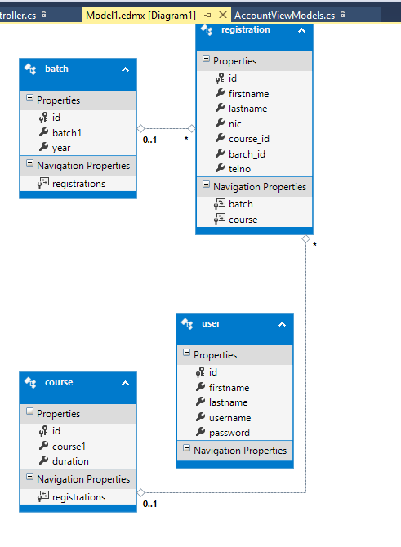

## Views:

## Account:

### ExternalLogins

@model Student_Management_System.Models.ExternalLoginListViewModel

@using Microsoft.Owin.Security

<h4>Use another service to log in.</h4>

<hr />

@{

var loginProviders = Context.GetOwinContext().Authentication.GetExternalAuthenticationTypes();

if (loginProviders.Count() == 0) {

<div>

<p>

There are no external authentication services configured. See <a href="http://go.microsoft.com/fwlink/?LinkId=403804">this article</a>

for details on setting up this ASP.NET application to support logging in via external services.

</p>

</div>

}

else {

using (Html.BeginForm("ExternalLogin", "Account", new { ReturnUrl = Model.ReturnUrl })) {

@Html.AntiForgeryToken()

<div id="socialLoginList">

<p>

@foreach (AuthenticationDescription p in loginProviders) {

<button type="submit" class="btn btn-default" id="@p.AuthenticationType" name="provider" value="@p.AuthenticationType" title="Log in using your @p.Caption account">@p.AuthenticationType</button>

}

</p>

</div>

}

}

}

### ConfirmEmail

@{

ViewBag.Title = "Confirm Email";

}

<h2>@ViewBag.Title.</h2>

<div>

<p>

Thank you for confirming your email. Please @Html.ActionLink("Click here to Log in", "Login", "Account", routeValues: null, htmlAttributes: new { id = "loginLink" })

</p>

</div>

### ExternalLoginConfirmation

@model Student_Management_System.Models.ExternalLoginConfirmationViewModel

@{

ViewBag.Title = "Register";

}

<h2>@ViewBag.Title.</h2>

<h3>Associate your @ViewBag.LoginProvider account.</h3>

@using (Html.BeginForm("ExternalLoginConfirmation", "Account", new { ReturnUrl = ViewBag.ReturnUrl }, FormMethod.Post, new { @class = "form-horizontal", role = "form" }))

{

@Html.AntiForgeryToken()

<h4>Association Form</h4>

<hr />

@Html.ValidationSummary(true, "", new { @class = "text-danger" })

<p class="text-info">

You've successfully authenticated with <strong>@ViewBag.LoginProvider</strong>.

Please enter a user name for this site below and click the Register button to finish

logging in.

</p>

<div class="form-group">

@Html.LabelFor(m => m.Email, new { @class = "col-md-2 control-label" })

<div class="col-md-10">

@Html.TextBoxFor(m => m.Email, new { @class = "form-control" })

@Html.ValidationMessageFor(m => m.Email, "", new { @class = "text-danger" })

</div>

</div>

<div class="form-group">

<div class="col-md-offset-2 col-md-10">

<input type="submit" class="btn btn-default" value="Register" />

</div>

</div>

}

@section Scripts {

@Scripts.Render("~/bundles/jqueryval")

}

### ExternalLoginFailure

@{

ViewBag.Title = "Login Failure";

}

<hgroup>

<h2>@ViewBag.Title.</h2>

<h3 class="text-danger">Unsuccessful login with service.</h3>

</hgroup>

### ForgotPassword

@model Student_Management_System.Models.ForgotPasswordViewModel

@{

ViewBag.Title = "Forgot your password?";

}

<h2>@ViewBag.Title.</h2>

@using (Html.BeginForm("ForgotPassword", "Account", FormMethod.Post, new { @class = "form-horizontal", role = "form" }))

{

@Html.AntiForgeryToken()

<h4>Enter your email.</h4>

<hr />

@Html.ValidationSummary("", new { @class = "text-danger" })

<div class="form-group">

@Html.LabelFor(m => m.Email, new { @class = "col-md-2 control-label" })

<div class="col-md-10">

@Html.TextBoxFor(m => m.Email, new { @class = "form-control" })

</div>

</div>

<div class="form-group">

<div class="col-md-offset-2 col-md-10">

<input type="submit" class="btn btn-default" value="Email Link" />

</div>

</div>

}

@section Scripts {

@Scripts.Render("~/bundles/jqueryval")

}

### ForgotPasswordConfirmation

@{

ViewBag.Title = "Forgot Password Confirmation";

}

<hgroup class="title">

<h1>@ViewBag.Title.</h1>

</hgroup>

<div>

<p>

Please check your email to reset your password.

</p>

</div>

### Login

@using Student_Management_System.Models

@model LoginViewModel

@{

ViewBag.Title = "Log in";

}

<h2>@ViewBag.Title.</h2>

<div class="row">

<div class="col-md-8">

<section id="loginForm">

@using (Html.BeginForm("Login", "Account", new { ReturnUrl = ViewBag.ReturnUrl }, FormMethod.Post, new { @class = "form-horizontal", role = "form" }))

{

@Html.AntiForgeryToken()

<h4>Use a local account to log in.</h4>

<hr />

@Html.ValidationSummary(true, "", new { @class = "text-danger" })

<div class="form-group">

@Html.LabelFor(m => m.Email, new { @class = "col-md-2 control-label" })

<div class="col-md-10">

@Html.TextBoxFor(m => m.Email, new { @class = "form-control" })

@Html.ValidationMessageFor(m => m.Email, "", new { @class = "text-danger" })

</div>

</div>

<div class="form-group">

@Html.LabelFor(m => m.Password, new { @class = "col-md-2 control-label" })

<div class="col-md-10">

@Html.PasswordFor(m => m.Password, new { @class = "form-control" })

@Html.ValidationMessageFor(m => m.Password, "", new { @class = "text-danger" })

</div>

</div>

<div class="form-group">

<div class="col-md-offset-2 col-md-10">

<div class="checkbox">

@Html.CheckBoxFor(m => m.RememberMe)

@Html.LabelFor(m => m.RememberMe)

</div>

</div>

</div>

<div class="form-group">

<div class="col-md-offset-2 col-md-10">

<input type="submit" value="Log in" class="btn btn-default" />

</div>

</div>

<p>

@Html.ActionLink("Register as a new user", "Register")

</p>

@* Enable this once you have account confirmation enabled for password reset functionality

<p>

@Html.ActionLink("Forgot your password?", "ForgotPassword")

</p>*@

}

</section>

</div>

<div class="col-md-4">

<section id="socialLoginForm">

@Html.Partial("_ExternalLoginsListPartial", new ExternalLoginListViewModel { ReturnUrl = ViewBag.ReturnUrl })

</section>

</div>

</div>

@section Scripts {

@Scripts.Render("~/bundles/jqueryval")

}

### Register

@model Student_Management_System.Models.RegisterViewModel

@{

ViewBag.Title = "Register";

}

<h2>@ViewBag.Title.</h2>

@using (Html.BeginForm("Register", "Account", FormMethod.Post, new { @class = "form-horizontal", role = "form" }))

{

@Html.AntiForgeryToken()

<h4>Create a new account.</h4>

<hr />

@Html.ValidationSummary("", new { @class = "text-danger" })

<div class="form-group">

@Html.LabelFor(m => m.Email, new { @class = "col-md-2 control-label" })

<div class="col-md-10">

@Html.TextBoxFor(m => m.Email, new { @class = "form-control" })

</div>

</div>

<div class="form-group">

@Html.LabelFor(m => m.Password, new { @class = "col-md-2 control-label" })

<div class="col-md-10">

@Html.PasswordFor(m => m.Password, new { @class = "form-control" })

</div>

</div>

<div class="form-group">

@Html.LabelFor(m => m.ConfirmPassword, new { @class = "col-md-2 control-label" })

<div class="col-md-10">

@Html.PasswordFor(m => m.ConfirmPassword, new { @class = "form-control" })

</div>

</div>

<div class="form-group">

<div class="col-md-offset-2 col-md-10">

<input type="submit" class="btn btn-default" value="Register" />

</div>

</div>

}

@section Scripts {

@Scripts.Render("~/bundles/jqueryval")

}

### ResetPassword

@model Student_Management_System.Models.RegisterViewModel

@{

ViewBag.Title = "Register";

}

<h2>@ViewBag.Title.</h2>

@using (Html.BeginForm("Register", "Account", FormMethod.Post, new { @class = "form-horizontal", role = "form" }))

{

@Html.AntiForgeryToken()

<h4>Create a new account.</h4>

<hr />

@Html.ValidationSummary("", new { @class = "text-danger" })

<div class="form-group">

@Html.LabelFor(m => m.Email, new { @class = "col-md-2 control-label" })

<div class="col-md-10">

@Html.TextBoxFor(m => m.Email, new { @class = "form-control" })

</div>

</div>

<div class="form-group">

@Html.LabelFor(m => m.Password, new { @class = "col-md-2 control-label" })

<div class="col-md-10">

@Html.PasswordFor(m => m.Password, new { @class = "form-control" })

</div>

</div>

<div class="form-group">

@Html.LabelFor(m => m.ConfirmPassword, new { @class = "col-md-2 control-label" })

<div class="col-md-10">

@Html.PasswordFor(m => m.ConfirmPassword, new { @class = "form-control" })

</div>

</div>

<div class="form-group">

<div class="col-md-offset-2 col-md-10">

<input type="submit" class="btn btn-default" value="Register" />

</div>

</div>

}

@section Scripts {

@Scripts.Render("~/bundles/jqueryval")

}

### ResetPasswordConfirmation

@{

ViewBag.Title = "Reset password confirmation";

}

<hgroup class="title">

<h1>@ViewBag.Title.</h1>

</hgroup>

<div>

<p>

Your password has been reset. Please @Html.ActionLink("click here to log in", "Login", "Account", routeValues: null, htmlAttributes: new { id = "loginLink" })

</p>

</div>

### SendCode

@model Student_Management_System.Models.SendCodeViewModel

@{

ViewBag.Title = "Send";

}

<h2>@ViewBag.Title.</h2>

@using (Html.BeginForm("SendCode", "Account", new { ReturnUrl = Model.ReturnUrl }, FormMethod.Post, new { @class = "form-horizontal", role = "form" })) {

@Html.AntiForgeryToken()

@Html.Hidden("rememberMe", @Model.RememberMe)

<h4>Send verification code</h4>

<hr />

<div class="row">

<div class="col-md-8">

Select Two-Factor Authentication Provider:

@Html.DropDownListFor(model => model.SelectedProvider, Model.Providers)

<input type="submit" value="Submit" class="btn btn-default" />

</div>

</div>

}

@section Scripts {

@Scripts.Render("~/bundles/jqueryval")

}

### VerifyCode

@model Student_Management_System.Models.VerifyCodeViewModel

@{

ViewBag.Title = "Verify";

}

<h2>@ViewBag.Title.</h2>

@using (Html.BeginForm("VerifyCode", "Account", new { ReturnUrl = Model.ReturnUrl }, FormMethod.Post, new { @class = "form-horizontal", role = "form" })) {

@Html.AntiForgeryToken()

@Html.Hidden("provider", @Model.Provider)

@Html.Hidden("rememberMe", @Model.RememberMe)

<h4>Enter verification code</h4>

<hr />

@Html.ValidationSummary("", new { @class = "text-danger" })

<div class="form-group">

@Html.LabelFor(m => m.Code, new { @class = "col-md-2 control-label" })

<div class="col-md-10">

@Html.TextBoxFor(m => m.Code, new { @class = "form-control" })

</div>

</div>

<div class="form-group">

<div class="col-md-offset-2 col-md-10">

<div class="checkbox">

@Html.CheckBoxFor(m => m.RememberBrowser)

@Html.LabelFor(m => m.RememberBrowser)

</div>

</div>

</div>

<div class="form-group">

<div class="col-md-offset-2 col-md-10">

<input type="submit" class="btn btn-default" value="Submit" />

</div>

</div>

}

@section Scripts {

@Scripts.Render("~/bundles/jqueryval")

}

## Batch

### Create

@model Student_Management_System.Models.batch

@{

ViewBag.Title = "Create";

}

<h2>Create</h2>

@using (Html.BeginForm())

{

@Html.AntiForgeryToken()

<div class="form-horizontal">

<h4>batch</h4>

<hr />

@Html.ValidationSummary(true, "", new { @class = "text-danger" })

<div class="form-group">

@Html.LabelFor(model => model.batch1, htmlAttributes: new { @class = "control-label col-md-2" })

<div class="col-md-10">

@Html.EditorFor(model => model.batch1, new { htmlAttributes = new { @class = "form-control" } })

@Html.ValidationMessageFor(model => model.batch1, "", new { @class = "text-danger" })

</div>

</div>

<div class="form-group">

@Html.LabelFor(model => model.year, htmlAttributes: new { @class = "control-label col-md-2" })

<div class="col-md-10">

@Html.EditorFor(model => model.year, new { htmlAttributes = new { @class = "form-control" } })

@Html.ValidationMessageFor(model => model.year, "", new { @class = "text-danger" })

</div>

</div>

<div class="form-group">

<div class="col-md-offset-2 col-md-10">

<input type="submit" value="Create" class="btn btn-default" />

</div>

</div>

</div>

}

<div>

@Html.ActionLink("Back to List", "Index")

</div>

@section Scripts {

@Scripts.Render("~/bundles/jqueryval")

}

### Delete

@model Student_Management_System.Models.batch

@{

ViewBag.Title = "Delete";

}

<h2>Delete</h2>

<h3>Are you sure you want to delete this?</h3>

<div>

<h4>batch</h4>

<hr />

<dl class="dl-horizontal">

<dt>

@Html.DisplayNameFor(model => model.batch1)

</dt>

<dd>

@Html.DisplayFor(model => model.batch1)

</dd>

<dt>

@Html.DisplayNameFor(model => model.year)

</dt>

<dd>

@Html.DisplayFor(model => model.year)

</dd>

</dl>

@using (Html.BeginForm()) {

@Html.AntiForgeryToken()

<div class="form-actions no-color">

<input type="submit" value="Delete" class="btn btn-default" /> |

@Html.ActionLink("Back to List", "Index")

</div>

}

</div>

### Details

@model Student_Management_System.Models.batch

@{

ViewBag.Title = "Details";

}

<h2>Details</h2>

<div>

<h4>batch</h4>

<hr />

<dl class="dl-horizontal">

<dt>

@Html.DisplayNameFor(model => model.batch1)

</dt>

<dd>

@Html.DisplayFor(model => model.batch1)

</dd>

<dt>

@Html.DisplayNameFor(model => model.year)

</dt>

<dd>

@Html.DisplayFor(model => model.year)

</dd>

</dl>

</div>

<p>

@Html.ActionLink("Edit", "Edit", new { id = Model.id }) |

@Html.ActionLink("Back to List", "Index")

</p>

### Edit

@model Student_Management_System.Models.batch

@{

ViewBag.Title = "Edit";

}

<h2>Edit</h2>

@using (Html.BeginForm())

{

@Html.AntiForgeryToken()

<div class="form-horizontal">

<h4>batch</h4>

<hr />

@Html.ValidationSummary(true, "", new { @class = "text-danger" })

@Html.HiddenFor(model => model.id)

<div class="form-group">

@Html.LabelFor(model => model.batch1, htmlAttributes: new { @class = "control-label col-md-2" })

<div class="col-md-10">

@Html.EditorFor(model => model.batch1, new { htmlAttributes = new { @class = "form-control" } })

@Html.ValidationMessageFor(model => model.batch1, "", new { @class = "text-danger" })

</div>

</div>

<div class="form-group">

@Html.LabelFor(model => model.year, htmlAttributes: new { @class = "control-label col-md-2" })

<div class="col-md-10">

@Html.EditorFor(model => model.year, new { htmlAttributes = new { @class = "form-control" } })

@Html.ValidationMessageFor(model => model.year, "", new { @class = "text-danger" })

</div>

</div>

<div class="form-group">

<div class="col-md-offset-2 col-md-10">

<input type="submit" value="Save" class="btn btn-default" />

</div>

</div>

</div>

}

<div>

@Html.ActionLink("Back to List", "Index")

</div>

@section Scripts {

@Scripts.Render("~/bundles/jqueryval")

}

### Index

@model IEnumerable<Student_Management_System.Models.batch>

@{

ViewBag.Title = "Index";

}

<h2>Index</h2>

<p>

@Html.ActionLink("Create New", "Create")

</p>

<table class="table">

<tr>

<th>

@Html.DisplayNameFor(model => model.batch1)

</th>

<th>

@Html.DisplayNameFor(model => model.year)

</th>

<th></th>

</tr>

@foreach (var item in Model) {

<tr>

<td>

@Html.DisplayFor(modelItem => item.batch1)

</td>

<td>

@Html.DisplayFor(modelItem => item.year)

</td>

<td>

@Html.ActionLink("Edit", "Edit", new { id=item.id }) |

@Html.ActionLink("Details", "Details", new { id=item.id }) |

@Html.ActionLink("Delete", "Delete", new { id=item.id })

</td>

</tr>

}

</table>

## Course

### Create

@model Student_Management_System.Models.course

@{

ViewBag.Title = "Create";

}

<h2>Create</h2>

@using (Html.BeginForm())

{

@Html.AntiForgeryToken()

<div class="form-horizontal">

<h4>course</h4>

<hr />

@Html.ValidationSummary(true, "", new { @class = "text-danger" })

<div class="form-group">

@Html.LabelFor(model => model.course1, htmlAttributes: new { @class = "control-label col-md-2" })

<div class="col-md-10">

@Html.EditorFor(model => model.course1, new { htmlAttributes = new { @class = "form-control" } })

@Html.ValidationMessageFor(model => model.course1, "", new { @class = "text-danger" })

</div>

</div>

<div class="form-group">

@Html.LabelFor(model => model.duration, htmlAttributes: new { @class = "control-label col-md-2" })

<div class="col-md-10">

@Html.EditorFor(model => model.duration, new { htmlAttributes = new { @class = "form-control" } })

@Html.ValidationMessageFor(model => model.duration, "", new { @class = "text-danger" })

</div>

</div>

<div class="form-group">

<div class="col-md-offset-2 col-md-10">

<input type="submit" value="Create" class="btn btn-default" />

</div>

</div>

</div>

}

<div>

@Html.ActionLink("Back to List", "Index")

</div>

@section Scripts {

@Scripts.Render("~/bundles/jqueryval")

}

### Delete

@model Student_Management_System.Models.course

@{

ViewBag.Title = "Delete";

}

<h2>Delete</h2>

<h3>Are you sure you want to delete this?</h3>

<div>

<h4>course</h4>

<hr />

<dl class="dl-horizontal">

<dt>

@Html.DisplayNameFor(model => model.course1)

</dt>

<dd>

@Html.DisplayFor(model => model.course1)

</dd>

<dt>

@Html.DisplayNameFor(model => model.duration)

</dt>

<dd>

@Html.DisplayFor(model => model.duration)

</dd>

</dl>

@using (Html.BeginForm()) {

@Html.AntiForgeryToken()

<div class="form-actions no-color">

<input type="submit" value="Delete" class="btn btn-default" /> |

@Html.ActionLink("Back to List", "Index")

</div>

}

</div>

### Details

@model Student_Management_System.Models.course

@{

ViewBag.Title = "Details";

}

<h2>Details</h2>

<div>

<h4>course</h4>

<hr />

<dl class="dl-horizontal">

<dt>

@Html.DisplayNameFor(model => model.course1)

</dt>

<dd>

@Html.DisplayFor(model => model.course1)

</dd>

<dt>

@Html.DisplayNameFor(model => model.duration)

</dt>

<dd>

@Html.DisplayFor(model => model.duration)

</dd>

</dl>

</div>

<p>

@Html.ActionLink("Edit", "Edit", new { id = Model.id }) |

@Html.ActionLink("Back to List", "Index")

</p>

### Edit

@model Student_Management_System.Models.course

@{

ViewBag.Title = "Edit";

}

<h2>Edit</h2>

@using (Html.BeginForm())

{

@Html.AntiForgeryToken()

<div class="form-horizontal">

<h4>course</h4>

<hr />

@Html.ValidationSummary(true, "", new { @class = "text-danger" })

@Html.HiddenFor(model => model.id)

<div class="form-group">

@Html.LabelFor(model => model.course1, htmlAttributes: new { @class = "control-label col-md-2" })

<div class="col-md-10">

@Html.EditorFor(model => model.course1, new { htmlAttributes = new { @class = "form-control" } })

@Html.ValidationMessageFor(model => model.course1, "", new { @class = "text-danger" })

</div>

</div>

<div class="form-group">

@Html.LabelFor(model => model.duration, htmlAttributes: new { @class = "control-label col-md-2" })

<div class="col-md-10">

@Html.EditorFor(model => model.duration, new { htmlAttributes = new { @class = "form-control" } })

@Html.ValidationMessageFor(model => model.duration, "", new { @class = "text-danger" })

</div>

</div>

<div class="form-group">

<div class="col-md-offset-2 col-md-10">

<input type="submit" value="Save" class="btn btn-default" />

</div>

</div>

</div>

}

<div>

@Html.ActionLink("Back to List", "Index")

</div>

@section Scripts {

@Scripts.Render("~/bundles/jqueryval")

}

### Index

@model IEnumerable<Student_Management_System.Models.course>

@{

ViewBag.Title = "Index";

}

<h2>Index</h2>

<p>

@Html.ActionLink("Create New", "Create")

</p>

<table class="table">

<tr>

<th>

@Html.DisplayNameFor(model => model.course1)

</th>

<th>

@Html.DisplayNameFor(model => model.duration)

</th>

<th></th>

</tr>

@foreach (var item in Model) {

<tr>

<td>

@Html.DisplayFor(modelItem => item.course1)

</td>

<td>

@Html.DisplayFor(modelItem => item.duration)

</td>

<td>

@Html.ActionLink("Edit", "Edit", new { id=item.id }) |

@Html.ActionLink("Details", "Details", new { id=item.id }) |

@Html.ActionLink("Delete", "Delete", new { id=item.id })

</td>

</tr>

}

</table>

# Home

### About

@{

ViewBag.Title = "About";

}

<h2>@ViewBag.Title.</h2>

<h3>@ViewBag.Message</h3>

<p>Use this area to provide additional information.</p>

### Contact

@{

ViewBag.Title = "Contact";

}

<h2>@ViewBag.Title.</h2>

<h3>@ViewBag.Message</h3>

<address>

One Microsoft Way<br />

Redmond, WA 98052-6399<br />

<abbr title="Phone">P:</abbr>

425.555.0100

</address>

<address>

<strong>Support:</strong> <a href="mailto:Support@example.com">Support@example.com</a><br />

<strong>Marketing:</strong> <a href="mailto:Marketing@example.com">Marketing@example.com</a>

</address>

### Index

@{

ViewBag.Title = "Home Page";

}

<div class="jumbotron">

<h1>ASP.NET</h1>

<p class="lead">ASP.NET is a free web framework for building great Web sites and Web applications using HTML, CSS and JavaScript.</p>

<p><a href="http://asp.net" class="btn btn-primary btn-lg">Learn more &raquo;</a></p>

</div>

<div class="row">

<div class="col-md-4">

<h2>Getting started</h2>

<p>

ASP.NET MVC gives you a powerful, patterns-based way to build dynamic websites that

enables a clean separation of concerns and gives you full control over markup

for enjoyable, agile development.

</p>

<p><a class="btn btn-default" href="http://go.microsoft.com/fwlink/?LinkId=301865">Learn more &raquo;</a></p>

</div>

<div class="col-md-4">

<h2>Get more libraries</h2>

<p>NuGet is a free Visual Studio extension that makes it easy to add, remove, and update libraries and tools in Visual Studio projects.</p>

<p><a class="btn btn-default" href="http://go.microsoft.com/fwlink/?LinkId=301866">Learn more &raquo;</a></p>

</div>

<div class="col-md-4">

<h2>Web Hosting</h2>

<p>You can easily find a web hosting company that offers the right mix of features and price for your applications.</p>

<p><a class="btn btn-default" href="http://go.microsoft.com/fwlink/?LinkId=301867">Learn more &raquo;</a></p>

</div>

</div>

## Login

### Index.cs.html

@model Student_Management_System.Models.user

@{

ViewBag.Title = "Create";

}

<h2>Create</h2>

@using (Html.BeginForm())

{

@Html.AntiForgeryToken()

<div class="form-horizontal">

<h4>user</h4>

<hr />

@Html.ValidationSummary(true, "", new { @class = "text-danger" })

<div class="form-group">

@Html.LabelFor(model => model.username, htmlAttributes: new { @class = "control-label col-md-2" })

<div class="col-md-10">

@Html.EditorFor(model => model.username, new { htmlAttributes = new { @class = "form-control" } })

@Html.ValidationMessageFor(model => model.username, "", new { @class = "text-danger" })

</div>

</div>

<div class="form-group">

@Html.LabelFor(model => model.password, htmlAttributes: new { @class = "control-label col-md-2" })

<div class="col-md-10">

@Html.PasswordFor(model => model.password, new { htmlAttributes = new { @class = "form-control" } })

@Html.ValidationMessageFor(model => model.password, "", new { @class = "text-danger" })

</div>

</div>

<div class="form-group">

<div class="col-md-offset-2 col-md-10">

<input type="submit" value="Login" class="btn btn-default" />

</div>

</div>

</div>

}

<div>

@Html.ActionLink("Back to List", "Index")

</div>

@section Scripts {

@Scripts.Render("~/bundles/jqueryval")

}

# Manage

### AddPhoneNumber

@model Student_Management_System.Models.AddPhoneNumberViewModel

@{

ViewBag.Title = "Phone Number";

}

<h2>@ViewBag.Title.</h2>

@using (Html.BeginForm("AddPhoneNumber", "Manage", FormMethod.Post, new { @class = "form-horizontal", role = "form" }))

{

@Html.AntiForgeryToken()

<h4>Add a phone number</h4>

<hr />

@Html.ValidationSummary("", new { @class = "text-danger" })

<div class="form-group">

@Html.LabelFor(m => m.Number, new { @class = "col-md-2 control-label" })

<div class="col-md-10">

@Html.TextBoxFor(m => m.Number, new { @class = "form-control" })

</div>

</div>

<div class="form-group">

<div class="col-md-offset-2 col-md-10">

<input type="submit" class="btn btn-default" value="Submit" />

</div>

</div>

}

@section Scripts {

@Scripts.Render("~/bundles/jqueryval")

}

### ChangePassword

@model Student_Management_System.Models.ChangePasswordViewModel

@{

ViewBag.Title = "Change Password";

}

<h2>@ViewBag.Title.</h2>

@using (Html.BeginForm("ChangePassword", "Manage", FormMethod.Post, new { @class = "form-horizontal", role = "form" }))

{

@Html.AntiForgeryToken()

<h4>Change Password Form</h4>

<hr />

@Html.ValidationSummary("", new { @class = "text-danger" })

<div class="form-group">

@Html.LabelFor(m => m.OldPassword, new { @class = "col-md-2 control-label" })

<div class="col-md-10">

@Html.PasswordFor(m => m.OldPassword, new { @class = "form-control" })

</div>

</div>

<div class="form-group">

@Html.LabelFor(m => m.NewPassword, new { @class = "col-md-2 control-label" })

<div class="col-md-10">

@Html.PasswordFor(m => m.NewPassword, new { @class = "form-control" })

</div>

</div>

<div class="form-group">

@Html.LabelFor(m => m.ConfirmPassword, new { @class = "col-md-2 control-label" })

<div class="col-md-10">

@Html.PasswordFor(m => m.ConfirmPassword, new { @class = "form-control" })

</div>

</div>

<div class="form-group">

<div class="col-md-offset-2 col-md-10">

<input type="submit" value="Change password" class="btn btn-default" />

</div>

</div>

}

@section Scripts {

@Scripts.Render("~/bundles/jqueryval")

}

### Index.cs.html

@model Student_Management_System.Models.IndexViewModel

@{

ViewBag.Title = "Manage";

}

<h2>@ViewBag.Title.</h2>

<p class="text-success">@ViewBag.StatusMessage</p>

<div>

<h4>Change your account settings</h4>

<hr />

<dl class="dl-horizontal">

<dt>Password:</dt>

<dd>

[

@if (Model.HasPassword)

{

@Html.ActionLink("Change your password", "ChangePassword")

}

else

{

@Html.ActionLink("Create", "SetPassword")

}

]

</dd>

<dt>External Logins:</dt>

<dd>

@Model.Logins.Count [

@Html.ActionLink("Manage", "ManageLogins") ]

</dd>

@*

Phone Numbers can used as a second factor of verification in a two-factor authentication system.

See <a href="http://go.microsoft.com/fwlink/?LinkId=403804">this article</a>

for details on setting up this ASP.NET application to support two-factor authentication using SMS.

Uncomment the following block after you have set up two-factor authentication

*@

@*

<dt>Phone Number:</dt>

<dd>

@(Model.PhoneNumber ?? "None")

@if (Model.PhoneNumber != null)

{

<br />

<text>[&nbsp;&nbsp;@Html.ActionLink("Change", "AddPhoneNumber")&nbsp;&nbsp;]</text>

using (Html.BeginForm("RemovePhoneNumber", "Manage", FormMethod.Post, new { @class = "form-horizontal", role = "form" }))

{

@Html.AntiForgeryToken()

<text>[<input type="submit" value="Remove" class="btn-link" />]</text>

}

}

else

{

<text>[&nbsp;&nbsp;@Html.ActionLink("Add", "AddPhoneNumber")

}

</dd>

*@

<dt>Two-Factor Authentication:</dt>

<dd>

<p>

There are no two-factor authentication providers configured. See <a href="http://go.microsoft.com/fwlink/?LinkId=403804">this article</a>

for details on setting up this ASP.NET application to support two-factor authentication.

</p>

@*@if (Model.TwoFactor)

{

using (Html.BeginForm("DisableTwoFactorAuthentication", "Manage", FormMethod.Post, new { @class = "form-horizontal", role = "form" }))

{

@Html.AntiForgeryToken()

<text>Enabled

<input type="submit" value="Disable" class="btn btn-link" />

</text>

}

}

else

{

using (Html.BeginForm("EnableTwoFactorAuthentication", "Manage", FormMethod.Post, new { @class = "form-horizontal", role = "form" }))

{

@Html.AntiForgeryToken()

<text>Disabled

<input type="submit" value="Enable" class="btn btn-link" />

</text>

}

}*@

</dd>

</dl>

</div>

### ManageLogins.cshtml

@model Student_Management_System.Models.ManageLoginsViewModel

@using Microsoft.Owin.Security

@{

ViewBag.Title = "Manage your external logins";

}

<h2>@ViewBag.Title.</h2>

<p class="text-success">@ViewBag.StatusMessage</p>

@{

var loginProviders = Context.GetOwinContext().Authentication.GetExternalAuthenticationTypes();

if (loginProviders.Count() == 0) {

<div>

<p>

There are no external authentication services configured. See <a href="http://go.microsoft.com/fwlink/?LinkId=313242">this article</a>

for details on setting up this ASP.NET application to support logging in via external services.

</p>

</div>

}

else

{

if (Model.CurrentLogins.Count > 0)

{

<h4>Registered Logins</h4>

<table class="table">

<tbody>

@foreach (var account in Model.CurrentLogins)

{

<tr>

<td>@account.LoginProvider</td>

<td>

@if (ViewBag.ShowRemoveButton)

{

using (Html.BeginForm("RemoveLogin", "Manage"))

{

@Html.AntiForgeryToken()

<div>

@Html.Hidden("loginProvider", account.LoginProvider)

@Html.Hidden("providerKey", account.ProviderKey)

<input type="submit" class="btn btn-default" value="Remove" title="Remove this @account.LoginProvider login from your account" />

</div>

}

}

else

{

@: &nbsp;

}

</td>

</tr>

}

</tbody>

</table>

}

if (Model.OtherLogins.Count > 0)

{

using (Html.BeginForm("LinkLogin", "Manage"))

{

@Html.AntiForgeryToken()

<div id="socialLoginList">

<p>

@foreach (AuthenticationDescription p in Model.OtherLogins)

{

<button type="submit" class="btn btn-default" id="@p.AuthenticationType" name="provider" value="@p.AuthenticationType" title="Log in using your @p.Caption account">@p.AuthenticationType</button>

}

</p>

</div>

}

}

}

}

### SetPassword.cshtml

@model Student_Management_System.Models.SetPasswordViewModel

@{

ViewBag.Title = "Create Password";

}

<h2>@ViewBag.Title.</h2>

<p class="text-info">

You do not have a local username/password for this site. Add a local

account so you can log in without an external login.

</p>

@using (Html.BeginForm("SetPassword", "Manage", FormMethod.Post, new { @class = "form-horizontal", role = "form" }))

{

@Html.AntiForgeryToken()

<h4>Create Local Login</h4>

<hr />

@Html.ValidationSummary("", new { @class = "text-danger" })

<div class="form-group">

@Html.LabelFor(m => m.NewPassword, new { @class = "col-md-2 control-label" })

<div class="col-md-10">

@Html.PasswordFor(m => m.NewPassword, new { @class = "form-control" })

</div>

</div>

<div class="form-group">

@Html.LabelFor(m => m.ConfirmPassword, new { @class = "col-md-2 control-label" })

<div class="col-md-10">

@Html.PasswordFor(m => m.ConfirmPassword, new { @class = "form-control" })

</div>

</div>

<div class="form-group">

<div class="col-md-offset-2 col-md-10">

<input type="submit" value="Set password" class="btn btn-default" />

</div>

</div>

}

@section Scripts {

@Scripts.Render("~/bundles/jqueryval")

}

### VerifyPhoneNumber.cshtml

@model Student_Management_System.Models.VerifyPhoneNumberViewModel

@{

ViewBag.Title = "Verify Phone Number";

}

<h2>@ViewBag.Title.</h2>

@using (Html.BeginForm("VerifyPhoneNumber", "Manage", FormMethod.Post, new { @class = "form-horizontal", role = "form" }))

{

@Html.AntiForgeryToken()

@Html.Hidden("phoneNumber", @Model.PhoneNumber)

<h4>Enter verification code</h4>

<h5>@ViewBag.Status</h5>

<hr />

@Html.ValidationSummary("", new { @class = "text-danger" })

<div class="form-group">

@Html.LabelFor(m => m.Code, new { @class = "col-md-2 control-label" })

<div class="col-md-10">

@Html.TextBoxFor(m => m.Code, new { @class = "form-control" })

</div>

</div>

<div class="form-group">

<div class="col-md-offset-2 col-md-10">

<input type="submit" class="btn btn-default" value="Submit" />

</div>

</div>

}

@section Scripts {

@Scripts.Render("~/bundles/jqueryval")

}

## Registration:

### Create

@model Student_Management_System.Models.registration

@{

ViewBag.Title = "Create";

}

<h2>Create</h2>

@using (Html.BeginForm())

{

@Html.AntiForgeryToken()

<div class="form-horizontal">

<h4>registration</h4>

<hr />

@Html.ValidationSummary(true, "", new { @class = "text-danger" })

<div class="form-group">

@Html.LabelFor(model => model.firstname, htmlAttributes: new { @class = "control-label col-md-2" })

<div class="col-md-10">

@Html.EditorFor(model => model.firstname, new { htmlAttributes = new { @class = "form-control" } })

@Html.ValidationMessageFor(model => model.firstname, "", new { @class = "text-danger" })

</div>

</div>

<div class="form-group">

@Html.LabelFor(model => model.lastname, htmlAttributes: new { @class = "control-label col-md-2" })

<div class="col-md-10">

@Html.EditorFor(model => model.lastname, new { htmlAttributes = new { @class = "form-control" } })

@Html.ValidationMessageFor(model => model.lastname, "", new { @class = "text-danger" })

</div>

</div>

<div class="form-group">

@Html.LabelFor(model => model.nic, htmlAttributes: new { @class = "control-label col-md-2" })

<div class="col-md-10">

@Html.EditorFor(model => model.nic, new { htmlAttributes = new { @class = "form-control" } })

@Html.ValidationMessageFor(model => model.nic, "", new { @class = "text-danger" })

</div>

</div>

<div class="form-group">

@Html.LabelFor(model => model.course_id, "course_id", htmlAttributes: new { @class = "control-label col-md-2" })

<div class="col-md-10">

@Html.DropDownList("course_id", null, htmlAttributes: new { @class = "form-control" })

@Html.ValidationMessageFor(model => model.course_id, "", new { @class = "text-danger" })

</div>

</div>

<div class="form-group">

@Html.LabelFor(model => model.barch_id, "barch_id", htmlAttributes: new { @class = "control-label col-md-2" })

<div class="col-md-10">

@Html.DropDownList("barch_id", null, htmlAttributes: new { @class = "form-control" })

@Html.ValidationMessageFor(model => model.barch_id, "", new { @class = "text-danger" })

</div>

</div>

<div class="form-group">

@Html.LabelFor(model => model.telno, htmlAttributes: new { @class = "control-label col-md-2" })

<div class="col-md-10">

@Html.EditorFor(model => model.telno, new { htmlAttributes = new { @class = "form-control" } })

@Html.ValidationMessageFor(model => model.telno, "", new { @class = "text-danger" })

</div>

</div>

<div class="form-group">

<div class="col-md-offset-2 col-md-10">

<input type="submit" value="Create" class="btn btn-default" />

</div>

</div>

</div>

}

<div>

@Html.ActionLink("Back to List", "Index")

</div>

@section Scripts {

@Scripts.Render("~/bundles/jqueryval")

}

### Delete

@model Student_Management_System.Models.registration

@{

ViewBag.Title = "Delete";

}

<h2>Delete</h2>

<h3>Are you sure you want to delete this?</h3>

<div>

<h4>registration</h4>

<hr />

<dl class="dl-horizontal">

<dt>

@Html.DisplayNameFor(model => model.firstname)

</dt>

<dd>

@Html.DisplayFor(model => model.firstname)

</dd>

<dt>

@Html.DisplayNameFor(model => model.lastname)

</dt>

<dd>

@Html.DisplayFor(model => model.lastname)

</dd>

<dt>

@Html.DisplayNameFor(model => model.nic)

</dt>

<dd>

@Html.DisplayFor(model => model.nic)

</dd>

<dt>

@Html.DisplayNameFor(model => model.telno)

</dt>

<dd>

@Html.DisplayFor(model => model.telno)

</dd>

<dt>

@Html.DisplayNameFor(model => model.batch.batch1)

</dt>

<dd>

@Html.DisplayFor(model => model.batch.batch1)

</dd>

<dt>

@Html.DisplayNameFor(model => model.course.course1)

</dt>

<dd>

@Html.DisplayFor(model => model.course.course1)

</dd>

</dl>

@using (Html.BeginForm()) {

@Html.AntiForgeryToken()

<div class="form-actions no-color">

<input type="submit" value="Delete" class="btn btn-default" /> |

@Html.ActionLink("Back to List", "Index")

</div>

}

</div>

### Details

@model Student_Management_System.Models.registration

@{

ViewBag.Title = "Details";

}

<h2>Details</h2>

<div>

<h4>registration</h4>

<hr />

<dl class="dl-horizontal">

<dt>

@Html.DisplayNameFor(model => model.firstname)

</dt>

<dd>

@Html.DisplayFor(model => model.firstname)

</dd>

<dt>

@Html.DisplayNameFor(model => model.lastname)

</dt>

<dd>

@Html.DisplayFor(model => model.lastname)

</dd>

<dt>

@Html.DisplayNameFor(model => model.nic)

</dt>

<dd>

@Html.DisplayFor(model => model.nic)

</dd>

<dt>

@Html.DisplayNameFor(model => model.telno)

</dt>

<dd>

@Html.DisplayFor(model => model.telno)

</dd>

<dt>

@Html.DisplayNameFor(model => model.batch.batch1)

</dt>

<dd>

@Html.DisplayFor(model => model.batch.batch1)

</dd>

<dt>

@Html.DisplayNameFor(model => model.course.course1)

</dt>

<dd>

@Html.DisplayFor(model => model.course.course1)

</dd>

</dl>

</div>

<p>

@Html.ActionLink("Edit", "Edit", new { id = Model.id }) |

@Html.ActionLink("Back to List", "Index")

</p>

### Edit

@model Student_Management_System.Models.registration

@{

ViewBag.Title = "Edit";

}

<h2>Edit</h2>

@using (Html.BeginForm())

{

@Html.AntiForgeryToken()

<div class="form-horizontal">

<h4>registration</h4>

<hr />

@Html.ValidationSummary(true, "", new { @class = "text-danger" })

@Html.HiddenFor(model => model.id)

<div class="form-group">

@Html.LabelFor(model => model.firstname, htmlAttributes: new { @class = "control-label col-md-2" })

<div class="col-md-10">

@Html.EditorFor(model => model.firstname, new { htmlAttributes = new { @class = "form-control" } })

@Html.ValidationMessageFor(model => model.firstname, "", new { @class = "text-danger" })

</div>

</div>

<div class="form-group">

@Html.LabelFor(model => model.lastname, htmlAttributes: new { @class = "control-label col-md-2" })

<div class="col-md-10">

@Html.EditorFor(model => model.lastname, new { htmlAttributes = new { @class = "form-control" } })

@Html.ValidationMessageFor(model => model.lastname, "", new { @class = "text-danger" })

</div>

</div>

<div class="form-group">

@Html.LabelFor(model => model.nic, htmlAttributes: new { @class = "control-label col-md-2" })

<div class="col-md-10">

@Html.EditorFor(model => model.nic, new { htmlAttributes = new { @class = "form-control" } })

@Html.ValidationMessageFor(model => model.nic, "", new { @class = "text-danger" })

</div>

</div>

<div class="form-group">

@Html.LabelFor(model => model.course_id, "course_id", htmlAttributes: new { @class = "control-label col-md-2" })

<div class="col-md-10">

@Html.DropDownList("course_id", null, htmlAttributes: new { @class = "form-control" })

@Html.ValidationMessageFor(model => model.course_id, "", new { @class = "text-danger" })

</div>

</div>

<div class="form-group">

@Html.LabelFor(model => model.barch_id, "barch_id", htmlAttributes: new { @class = "control-label col-md-2" })

<div class="col-md-10">

@Html.DropDownList("barch_id", null, htmlAttributes: new { @class = "form-control" })

@Html.ValidationMessageFor(model => model.barch_id, "", new { @class = "text-danger" })

</div>

</div>

<div class="form-group">

@Html.LabelFor(model => model.telno, htmlAttributes: new { @class = "control-label col-md-2" })

<div class="col-md-10">

@Html.EditorFor(model => model.telno, new { htmlAttributes = new { @class = "form-control" } })

@Html.ValidationMessageFor(model => model.telno, "", new { @class = "text-danger" })

</div>

</div>

<div class="form-group">

<div class="col-md-offset-2 col-md-10">

<input type="submit" value="Save" class="btn btn-default" />

</div>

</div>

</div>

}

<div>

@Html.ActionLink("Back to List", "Index")

</div>

@section Scripts {

@Scripts.Render("~/bundles/jqueryval")

}

### Index

@model IEnumerable<Student_Management_System.Models.registration>

@{

ViewBag.Title = "Index";

}

<h2>Index</h2>

<p>

@Html.ActionLink("Create New", "Create")

</p>

<table class="table">

<tr>

<th>

@Html.DisplayNameFor(model => model.firstname)

</th>

<th>

@Html.DisplayNameFor(model => model.lastname)

</th>

<th>

@Html.DisplayNameFor(model => model.nic)

</th>

<th>

@Html.DisplayNameFor(model => model.telno)

</th>

<th>

@Html.DisplayNameFor(model => model.batch.batch1)

</th>

<th>

@Html.DisplayNameFor(model => model.course.course1)

</th>

<th></th>

</tr>

@foreach (var item in Model) {

<tr>

<td>

@Html.DisplayFor(modelItem => item.firstname)

</td>

<td>

@Html.DisplayFor(modelItem => item.lastname)

</td>

<td>

@Html.DisplayFor(modelItem => item.nic)

</td>

<td>

@Html.DisplayFor(modelItem => item.telno)

</td>

<td>

@Html.DisplayFor(modelItem => item.batch.batch1)

</td>

<td>

@Html.DisplayFor(modelItem => item.course.course1)

</td>

<td>

@Html.ActionLink("Edit", "Edit", new { id=item.id }) |

@Html.ActionLink("Details", "Details", new { id=item.id }) |

@Html.ActionLink("Delete", "Delete", new { id=item.id })

</td>

</tr>

}

</table>

## Shared

### Layout.cshtml

<!DOCTYPE html>

<html>

<head>

<meta charset="utf-8" />

<meta name="viewport" content="width=device-width, initial-scale=1.0">

<title>@ViewBag.Title - My ASP.NET Application</title>

@Styles.Render("~/Content/css")

@Scripts.Render("~/bundles/modernizr")

</head>

<body>

<div class="navbar navbar-inverse navbar-fixed-top">

<div class="container">

<div class="navbar-header">

<button type="button" class="navbar-toggle" data-toggle="collapse" data-target=".navbar-collapse">

<span class="icon-bar"></span>

<span class="icon-bar"></span>

<span class="icon-bar"></span>

</button>

@Html.ActionLink("Application name", "Index", "Home", new { area = "" }, new { @class = "navbar-brand" })

</div>

<div class="navbar-collapse collapse">

<ul class="nav navbar-nav">

<li>@Html.ActionLink("Home", "Index", "Home")</li>

<li>@Html.ActionLink("Course", "Index", "Course")</li>

<li>@Html.ActionLink("Batch", "Index", "Batch")</li>

<li>@Html.ActionLink("Registration", "Index", "Registration")</li>

<li>@Html.ActionLink("User", "Index", "User")</li>

</ul>

<ul class="nav navbar-right" styyle="color=white">

@if (Session["userid"] != null)

{

<h4 style="color: white">Hello @Session["UserName"]</h4>

@Html.ActionLink("Logout","Logout","Login")

}

</ul>

@Html.Partial("_LoginPartial")

</div>

</div>

</div>

<div class="container body-content">

@RenderBody()

<hr />

<footer>

<p>&copy; @DateTime.Now.Year - My ASP.NET Application</p>

</footer>

</div>

@Scripts.Render("~/bundles/jquery")

@Scripts.Render("~/bundles/bootstrap")

@RenderSection("scripts", required: false)

</body>

</html>

### LoginPartial.cshtml

@using Microsoft.AspNet.Identity

@if (Request.IsAuthenticated)

{

using (Html.BeginForm("LogOff", "Account", FormMethod.Post, new { id = "logoutForm", @class = "navbar-right" }))

{

@Html.AntiForgeryToken()

<ul class="nav navbar-nav navbar-right">

<li>

@Html.ActionLink("Hello " + User.Identity.GetUserName() + "!", "Index", "Manage", routeValues: null, htmlAttributes: new { title = "Manage" })

</li>

<li><a href="javascript:document.getElementById('logoutForm').submit()">Log off</a></li>

</ul>

}

}

else

{

<ul class="nav navbar-nav navbar-right">

<li>@Html.ActionLink("Register", "Register", "Account", routeValues: null, htmlAttributes: new { id = "registerLink" })</li>

<li>@Html.ActionLink("Login", "Index", "Login", routeValues: null, htmlAttributes: new { id = "loginLink" })</li>

</ul>

}

### Error.cshtml

@model System.Web.Mvc.HandleErrorInfo

@{

ViewBag.Title = "Error";

}

<h1 class="text-danger">Error.</h1>

<h2 class="text-danger">An error occurred while processing your request.</h2>

### Lockout.cs.html

@model System.Web.Mvc.HandleErrorInfo

@{

ViewBag.Title = "Locked Out";

}

<hgroup>

<h1 class="text-danger">Locked out.</h1>

<h2 class="text-danger">This account has been locked out, please try again later.</h2>

</hgroup>

## User

### Create

@model Student_Management_System.Models.user

@{

ViewBag.Title = "Create";

}

<h2>Create</h2>

@using (Html.BeginForm())

{

@Html.AntiForgeryToken()

<div class="form-horizontal">

<h4>user</h4>

<hr />

@Html.ValidationSummary(true, "", new { @class = "text-danger" })

<div class="form-group">

@Html.LabelFor(model => model.firstname, htmlAttributes: new { @class = "control-label col-md-2" })

<div class="col-md-10">

@Html.EditorFor(model => model.firstname, new { htmlAttributes = new { @class = "form-control" } })

@Html.ValidationMessageFor(model => model.firstname, "", new { @class = "text-danger" })

</div>

</div>

<div class="form-group">

@Html.LabelFor(model => model.lastname, htmlAttributes: new { @class = "control-label col-md-2" })

<div class="col-md-10">

@Html.EditorFor(model => model.lastname, new { htmlAttributes = new { @class = "form-control" } })

@Html.ValidationMessageFor(model => model.lastname, "", new { @class = "text-danger" })

</div>

</div>

<div class="form-group">

@Html.LabelFor(model => model.username, htmlAttributes: new { @class = "control-label col-md-2" })

<div class="col-md-10">

@Html.EditorFor(model => model.username, new { htmlAttributes = new { @class = "form-control" } })

@Html.ValidationMessageFor(model => model.username, "", new { @class = "text-danger" })

</div>

</div>

<div class="form-group">

@Html.LabelFor(model => model.password, htmlAttributes: new { @class = "control-label col-md-2" })

<div class="col-md-10">

@Html.PasswordFor(model => model.password, new { htmlAttributes = new { @class = "form-control" } })

@Html.ValidationMessageFor(model => model.password, "", new { @class = "text-danger" })

</div>

</div>

<div class="form-group">

<div class="col-md-offset-2 col-md-10">

<input type="submit" value="Create" class="btn btn-default" />

</div>

</div>

</div>

}

<div>

@Html.ActionLink("Back to List", "Index")

</div>

@section Scripts {

@Scripts.Render("~/bundles/jqueryval")

}

### Delete

@model Student_Management_System.Models.user

@{

ViewBag.Title = "Delete";

}

<h2>Delete</h2>

<h3>Are you sure you want to delete this?</h3>

<div>

<h4>user</h4>

<hr />

<dl class="dl-horizontal">

<dt>

@Html.DisplayNameFor(model => model.firstname)

</dt>

<dd>

@Html.DisplayFor(model => model.firstname)

</dd>

<dt>

@Html.DisplayNameFor(model => model.lastname)

</dt>

<dd>

@Html.DisplayFor(model => model.lastname)

</dd>

<dt>

@Html.DisplayNameFor(model => model.username)

</dt>

<dd>

@Html.DisplayFor(model => model.username)

</dd>

<dt>

@Html.DisplayNameFor(model => model.password)

</dt>

<dd>

@Html.DisplayFor(model => model.password)

</dd>

</dl>

@using (Html.BeginForm()) {

@Html.AntiForgeryToken()

<div class="form-actions no-color">

<input type="submit" value="Delete" class="btn btn-default" /> |

@Html.ActionLink("Back to List", "Index")

</div>

}

</div>

### Details

@model Student_Management_System.Models.user

@{

ViewBag.Title = "Details";

}

<h2>Details</h2>

<div>

<h4>user</h4>

<hr />

<dl class="dl-horizontal">

<dt>

@Html.DisplayNameFor(model => model.firstname)

</dt>

<dd>

@Html.DisplayFor(model => model.firstname)

</dd>

<dt>

@Html.DisplayNameFor(model => model.lastname)

</dt>

<dd>

@Html.DisplayFor(model => model.lastname)

</dd>

<dt>

@Html.DisplayNameFor(model => model.username)

</dt>

<dd>

@Html.DisplayFor(model => model.username)

</dd>

<dt>

@Html.DisplayNameFor(model => model.password)

</dt>

<dd>

@Html.DisplayFor(model => model.password)

</dd>

</dl>

</div>

<p>

@Html.ActionLink("Edit", "Edit", new { id = Model.id }) |

@Html.ActionLink("Back to List", "Index")

</p>

### Edit

@model Student_Management_System.Models.user

@{

ViewBag.Title = "Details";

}

<h2>Details</h2>

<div>

<h4>user</h4>

<hr />

<dl class="dl-horizontal">

<dt>

@Html.DisplayNameFor(model => model.firstname)

</dt>

<dd>

@Html.DisplayFor(model => model.firstname)

</dd>

<dt>

@Html.DisplayNameFor(model => model.lastname)

</dt>

<dd>

@Html.DisplayFor(model => model.lastname)

</dd>

<dt>

@Html.DisplayNameFor(model => model.username)

</dt>

<dd>

@Html.DisplayFor(model => model.username)

</dd>

<dt>

@Html.DisplayNameFor(model => model.password)

</dt>

<dd>

@Html.DisplayFor(model => model.password)

</dd>

</dl>

</div>

<p>

@Html.ActionLink("Edit", "Edit", new { id = Model.id }) |

@Html.ActionLink("Back to List", "Index")

</p>

### Index

@model IEnumerable<Student_Management_System.Models.user>

@{

ViewBag.Title = "Index";

}

<h2>Index</h2>

<p>

@Html.ActionLink("Create New", "Create")

</p>

<table class="table">

<tr>

<th>

@Html.DisplayNameFor(model => model.firstname)

</th>

<th>

@Html.DisplayNameFor(model => model.lastname)

</th>

<th>

@Html.DisplayNameFor(model => model.username)

</th>

@* <th>

@Html.DisplayNameFor(model => model.password)

</th>*@

<th></th>

</tr>

@foreach (var item in Model) {

<tr>

<td>

@Html.DisplayFor(modelItem => item.firstname)

</td>

<td>

@Html.DisplayFor(modelItem => item.lastname)

</td>

<td>

@Html.DisplayFor(modelItem => item.username)

</td>

@*<td>

@Html.DisplayFor(modelItem => item.password)

</td>*@

<td>

@Html.ActionLink("Edit", "Edit", new { id=item.id }) |

@Html.ActionLink("Details", "Details", new { id=item.id }) |

@Html.ActionLink("Delete", "Delete", new { id=item.id })

</td>

</tr>

}

</table>

# Output

## Course

### Course Details

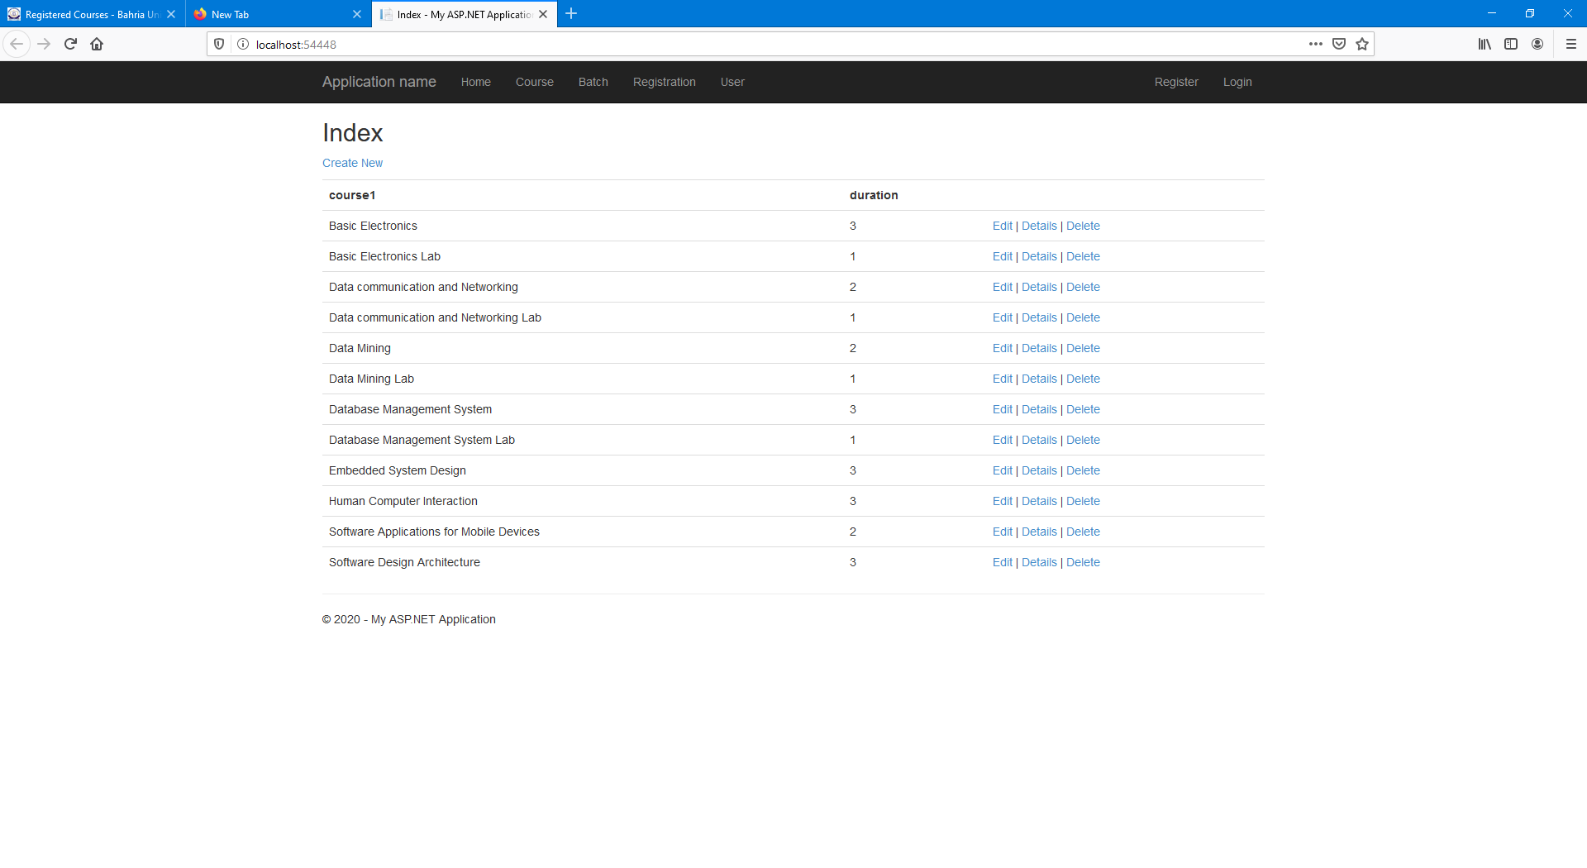

### Add Course

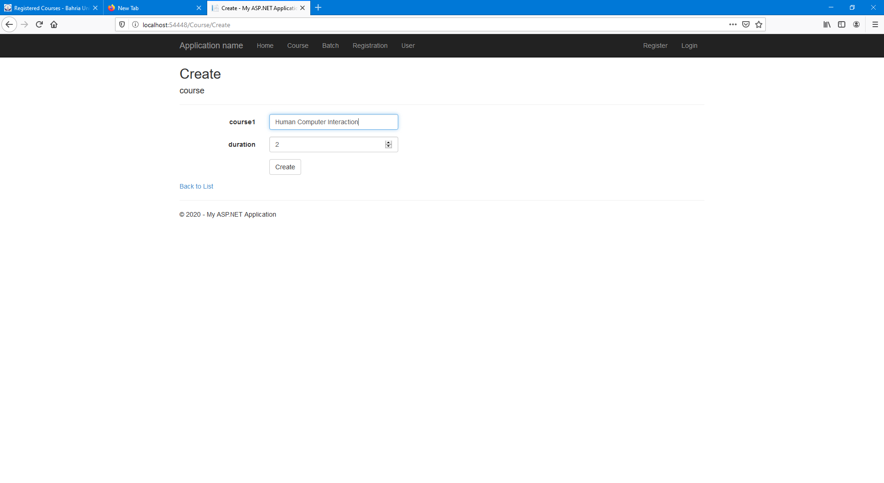

### View Course

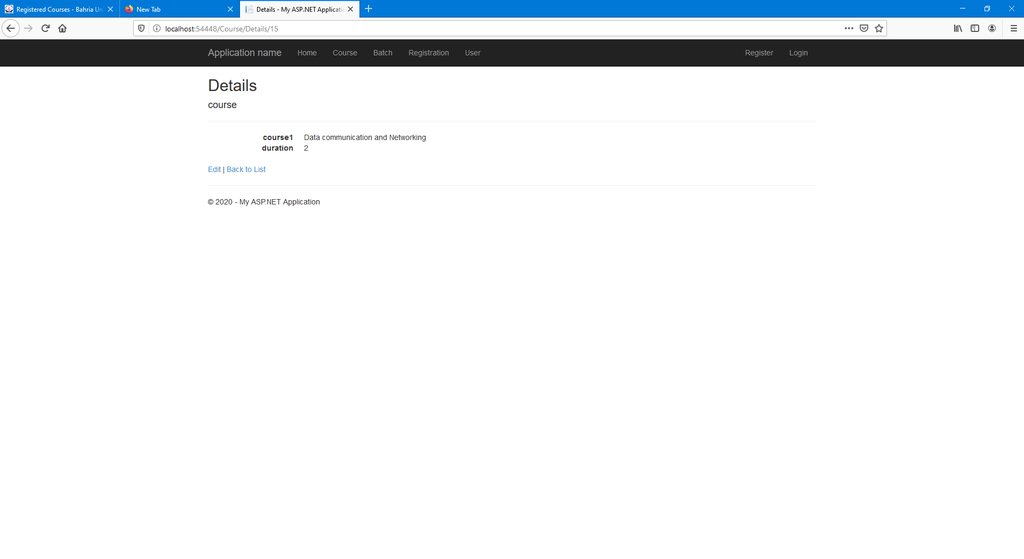

### Edit Course

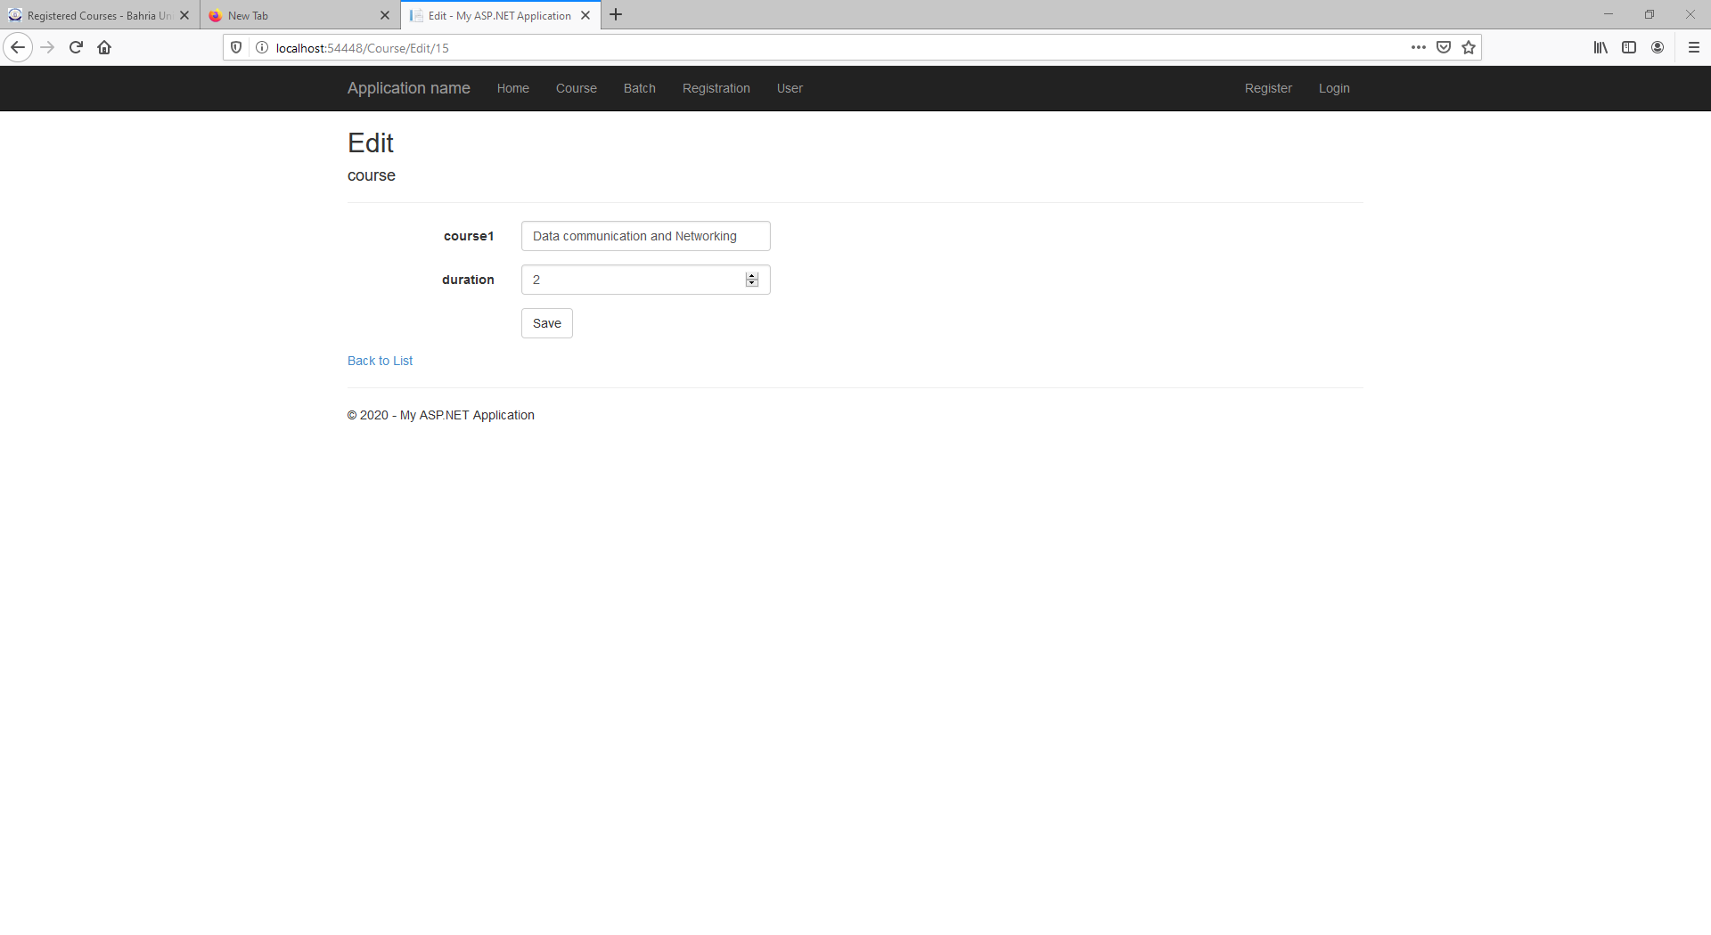

### Delete Course

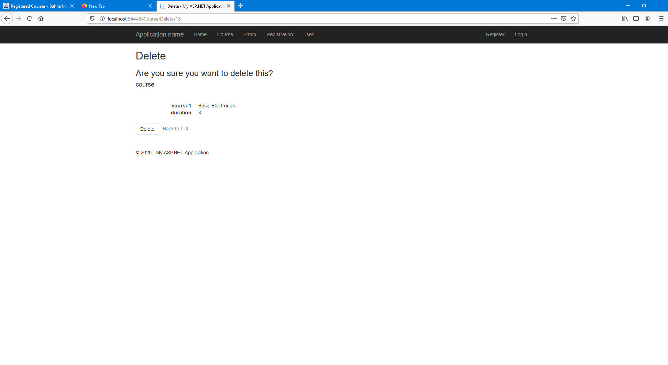

## Batch:

### Batch Details

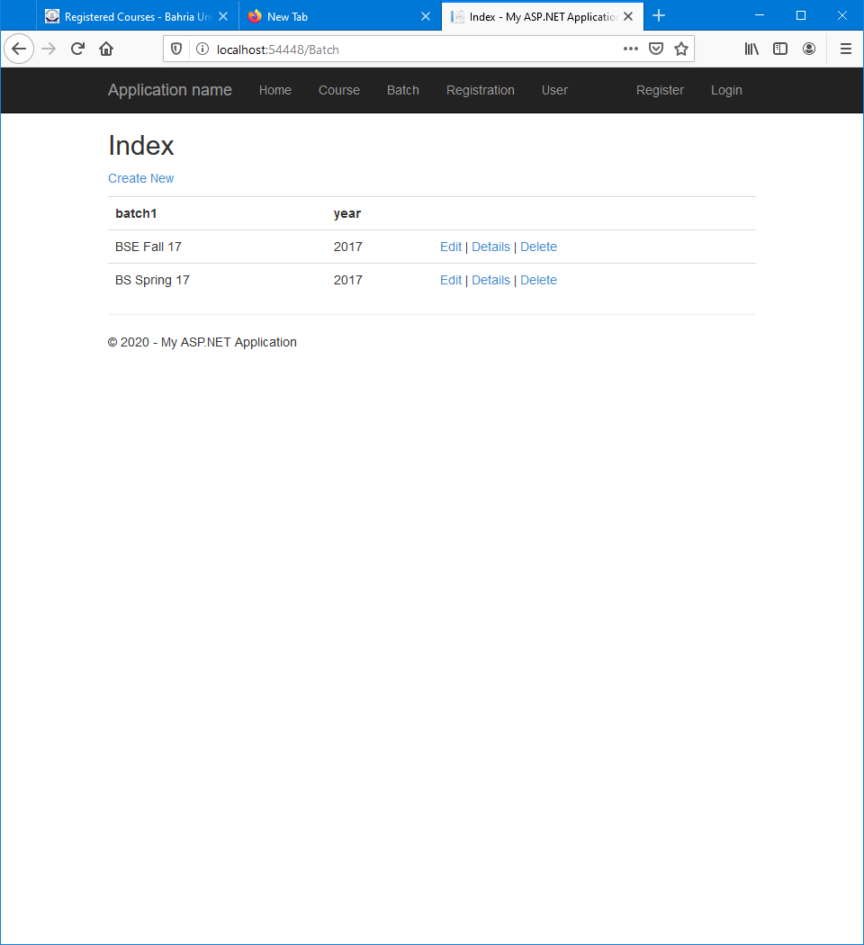

### Add Batch

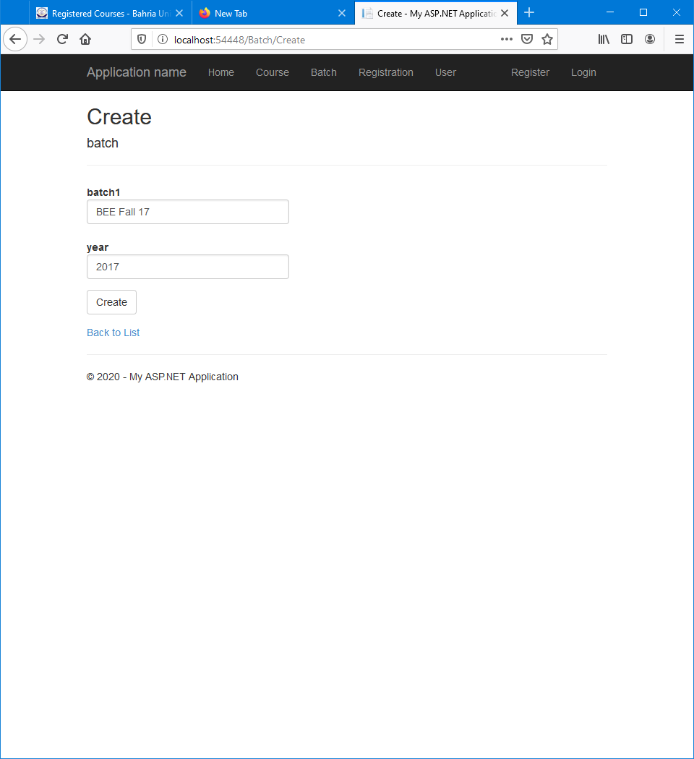

### View Batch

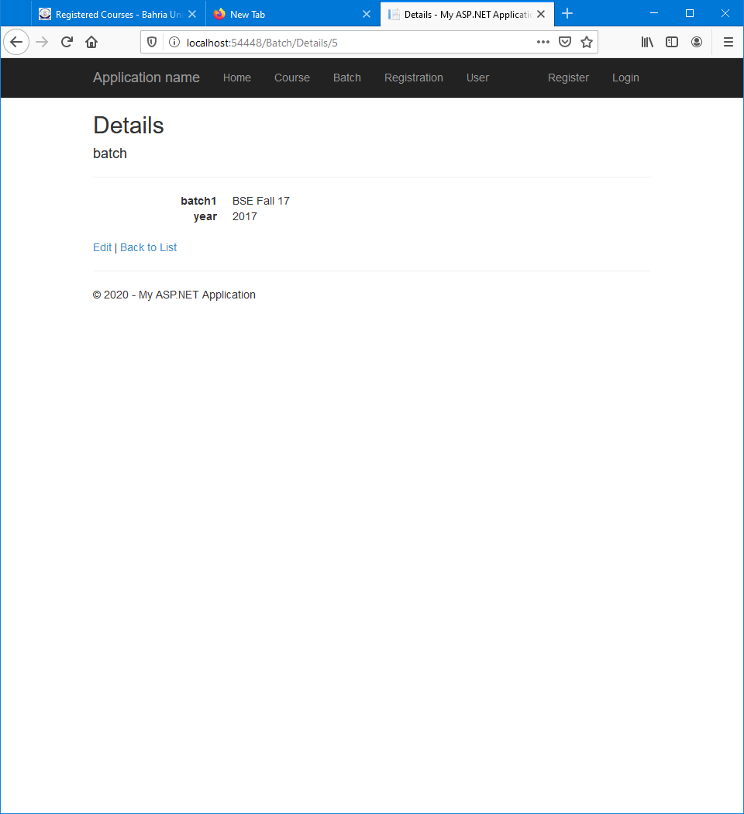

### Edit Batch

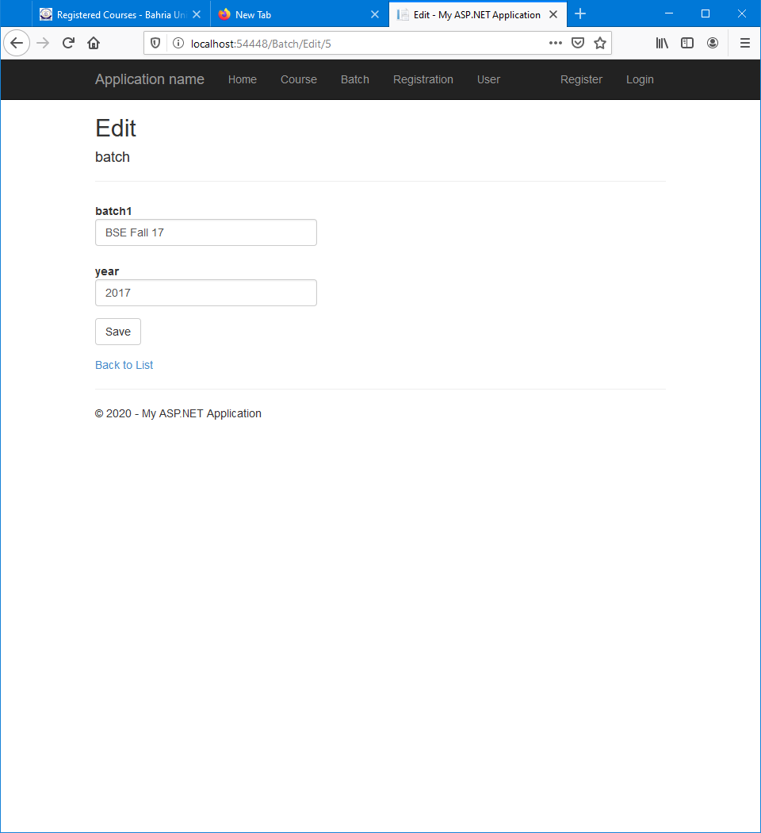

### Delete Batch

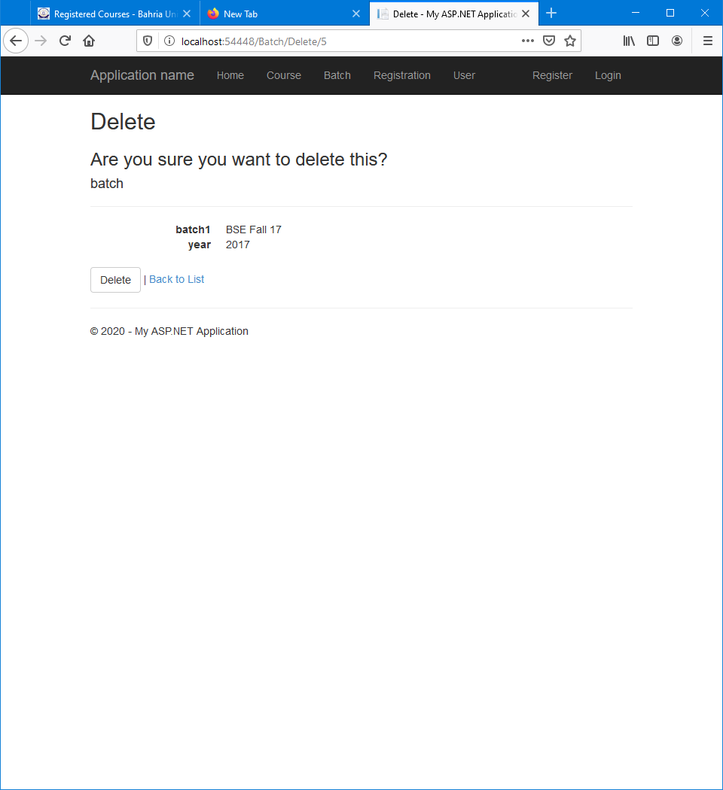

## Registration:

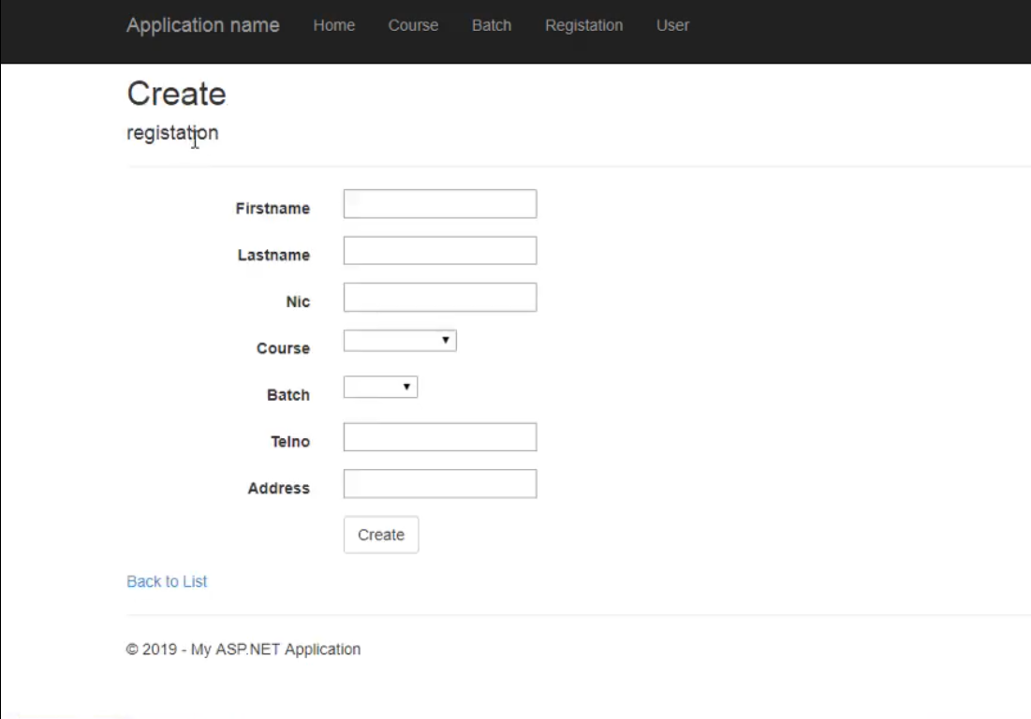

## User:

### User Details

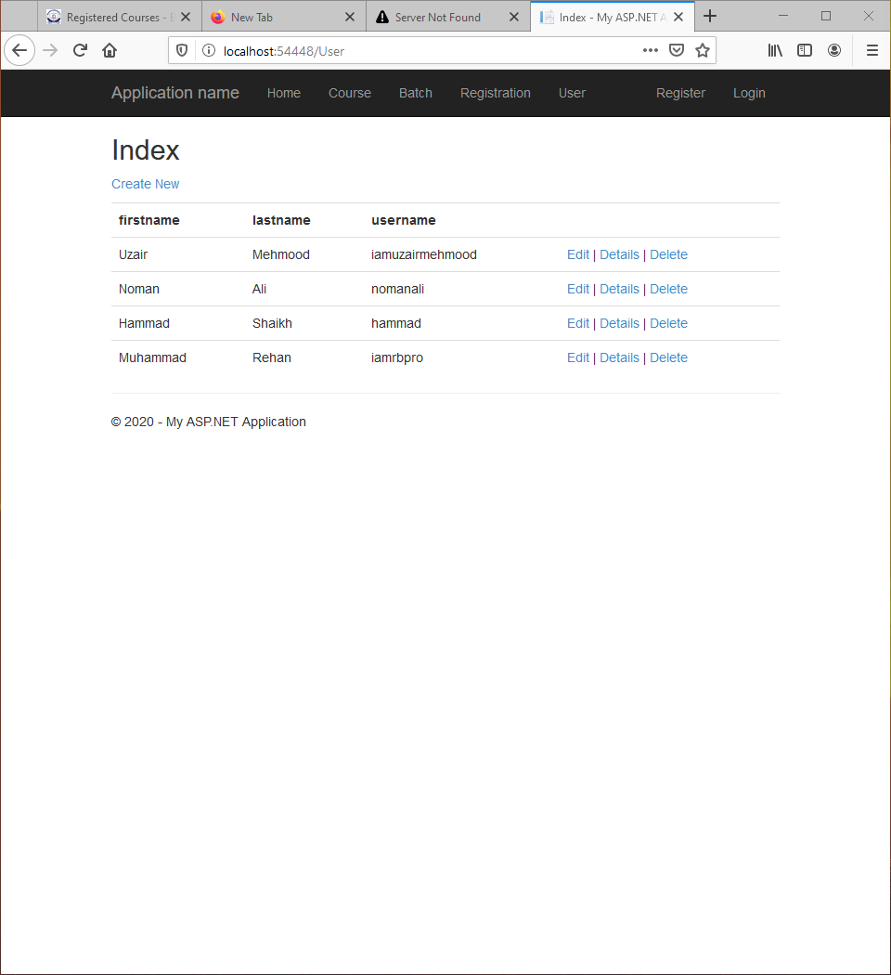

### Add User

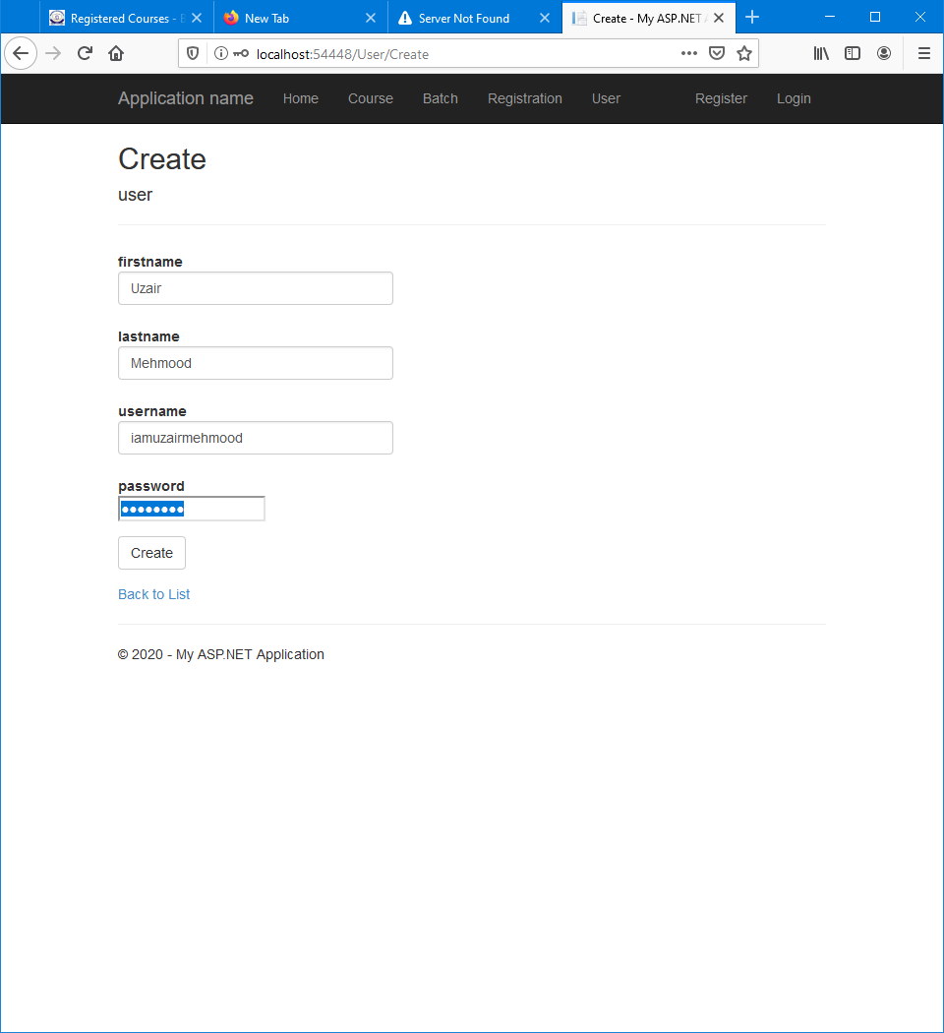

### View User

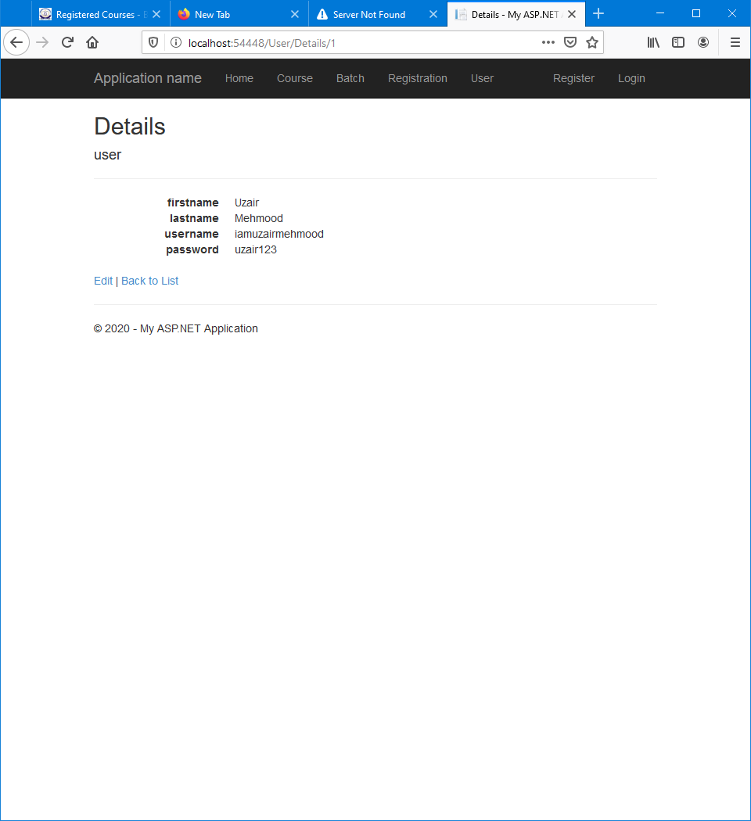

### Edit User

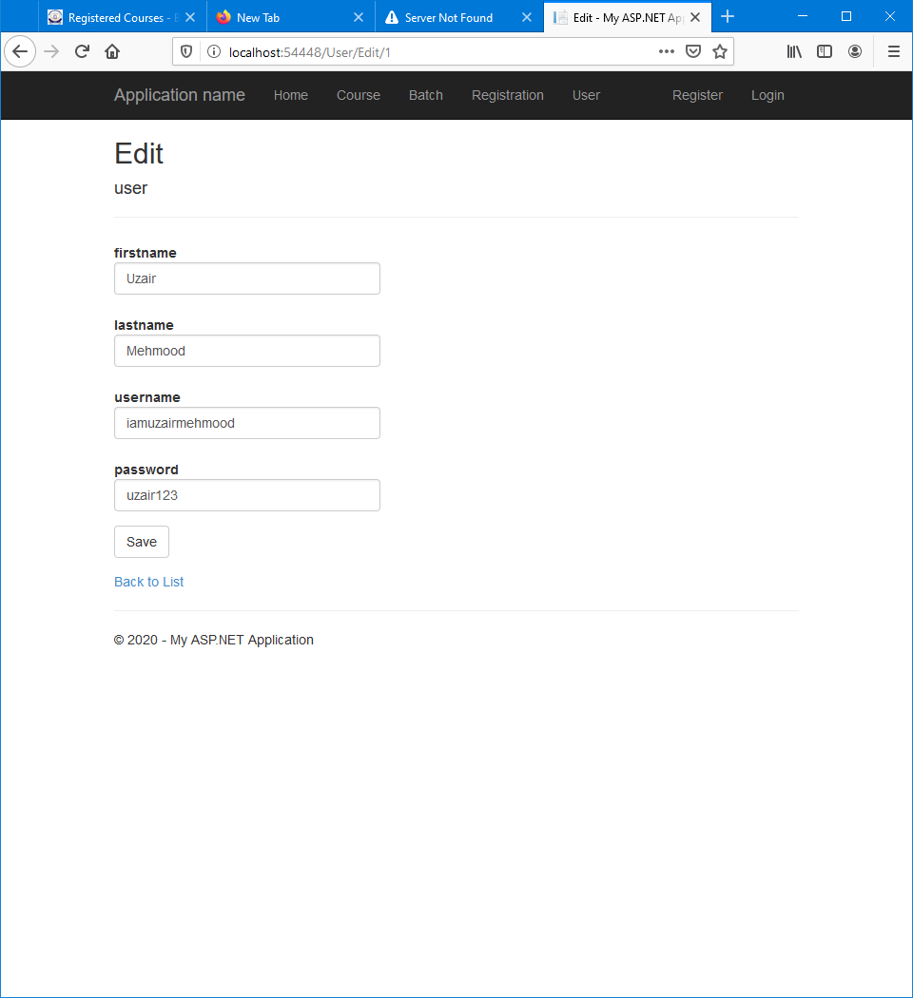

### Delete User

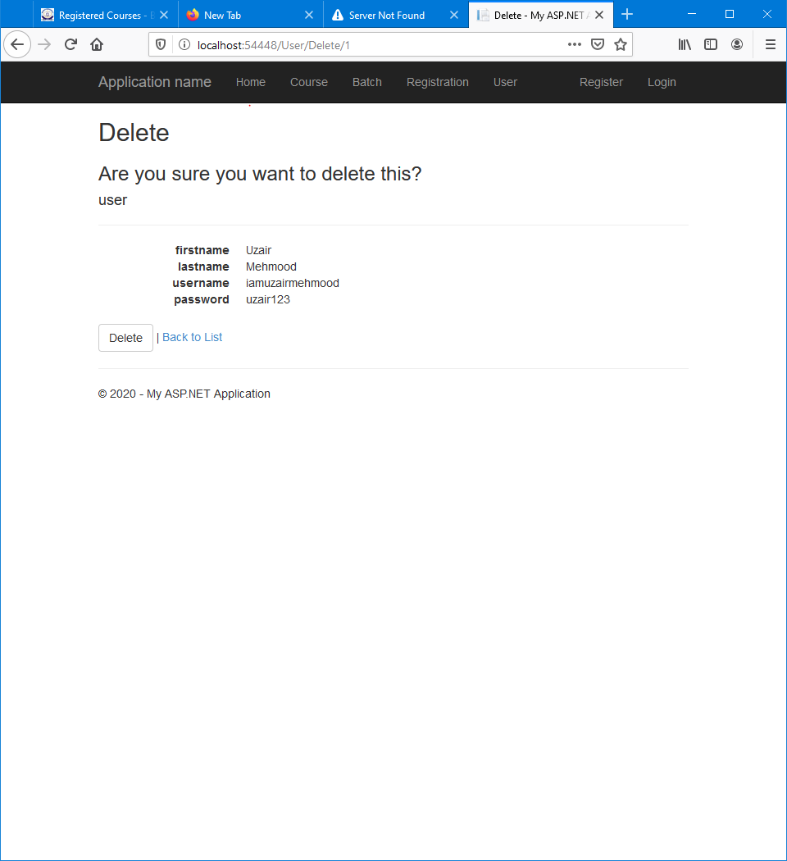

## Login

### Login View

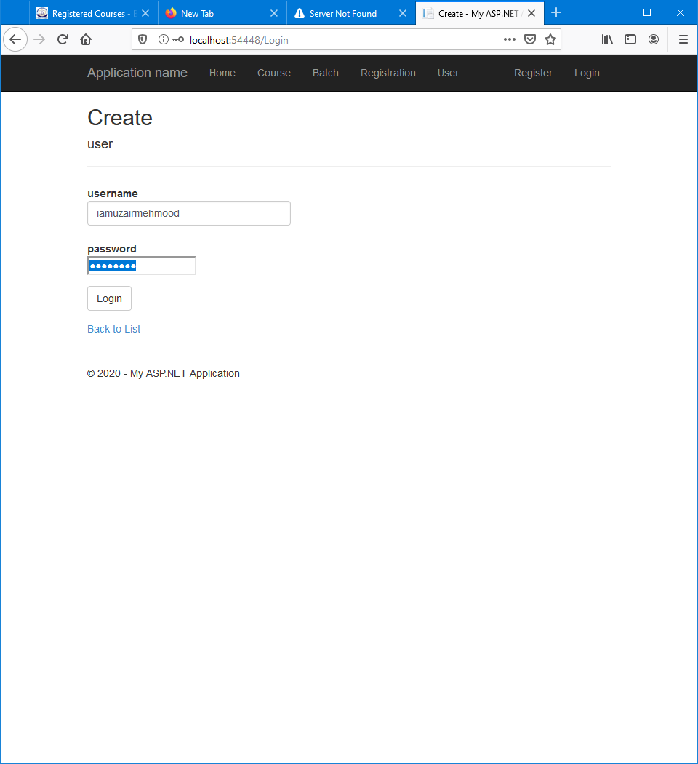

### Error

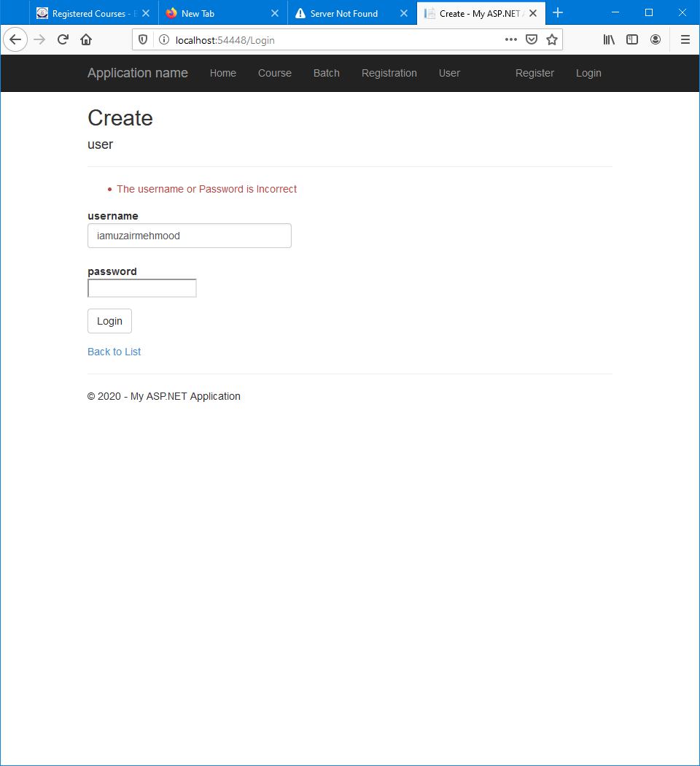

## Display User Name

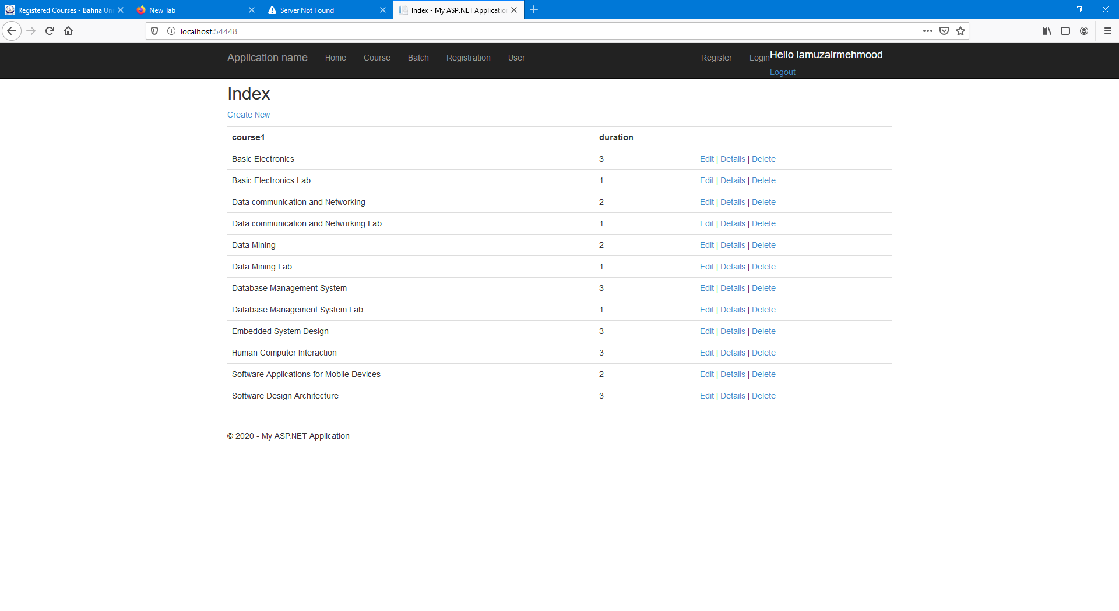

# Database

## Table-Design

### Batch

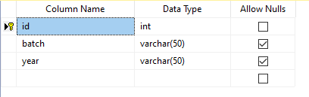

### Course

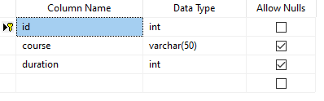

### Registration

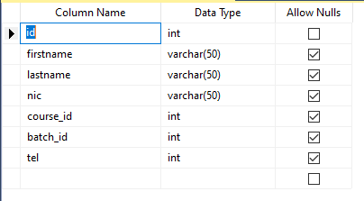

### User

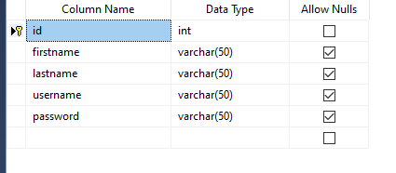

## Data In Tables

### Batch

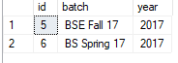

### Course

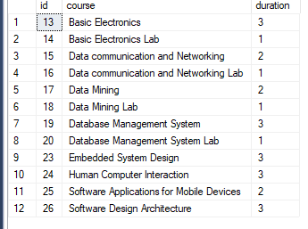

### Registration

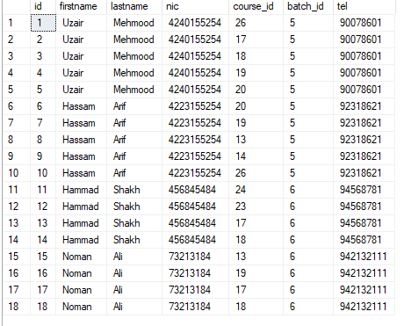

### User

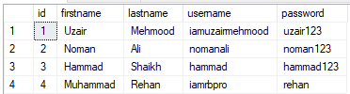

# Solution Expolrer

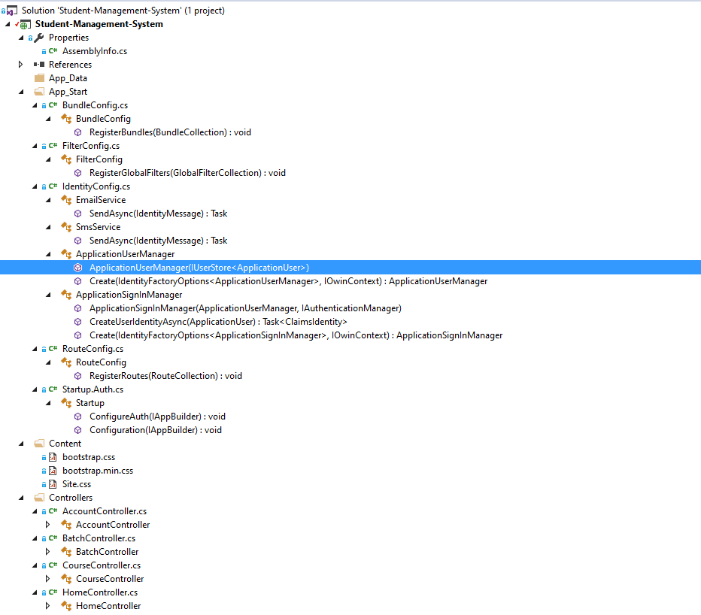

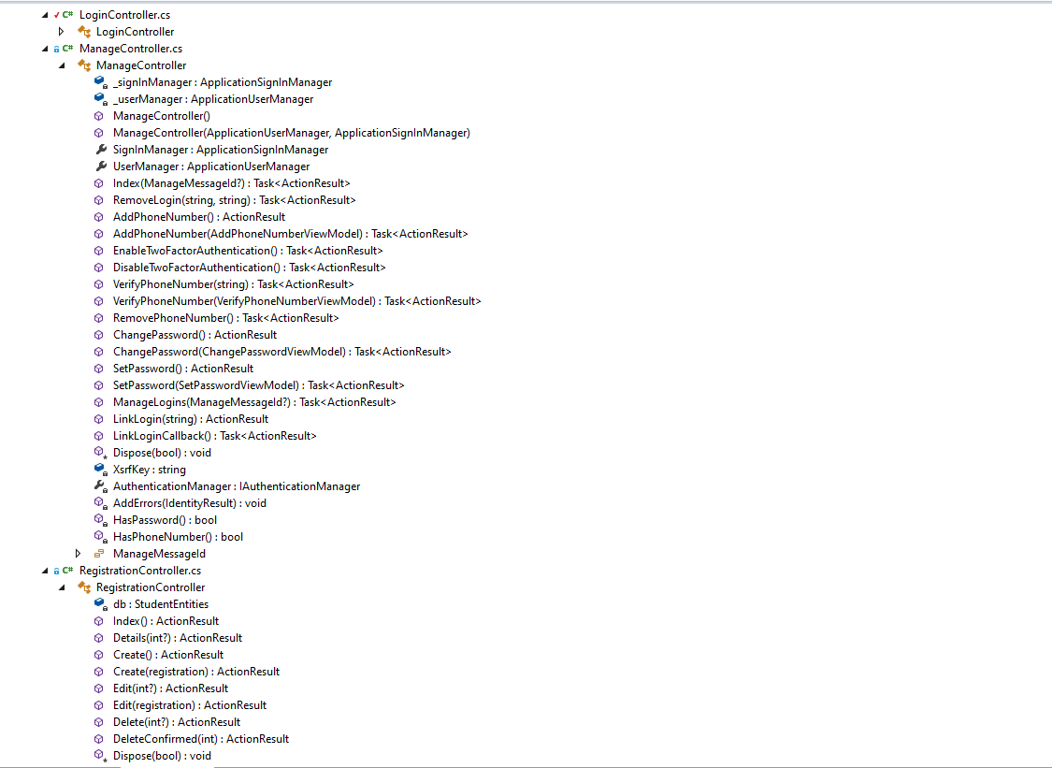

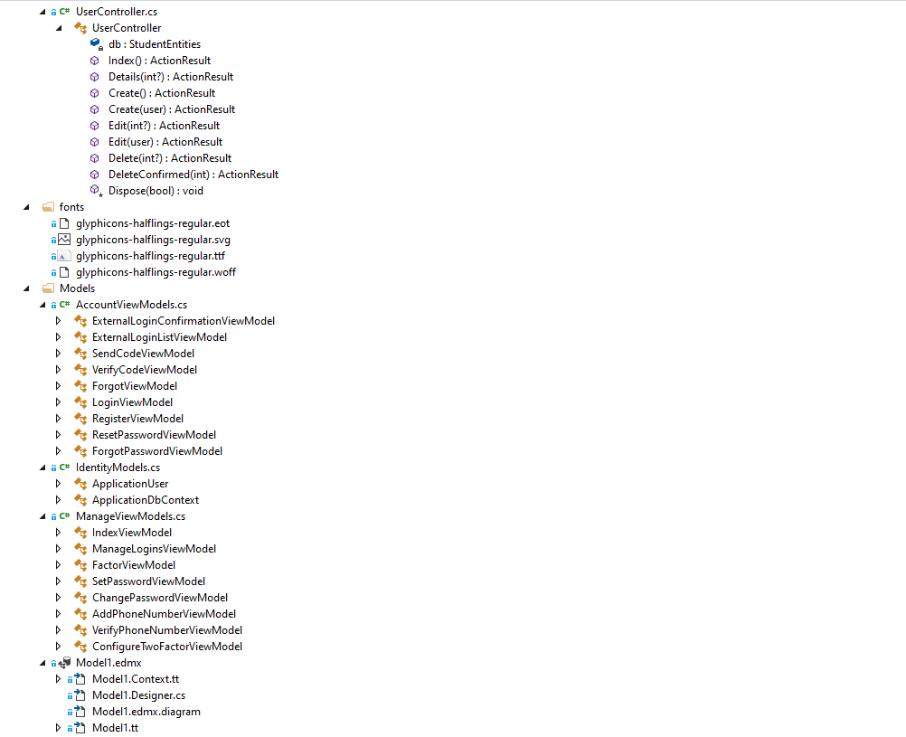

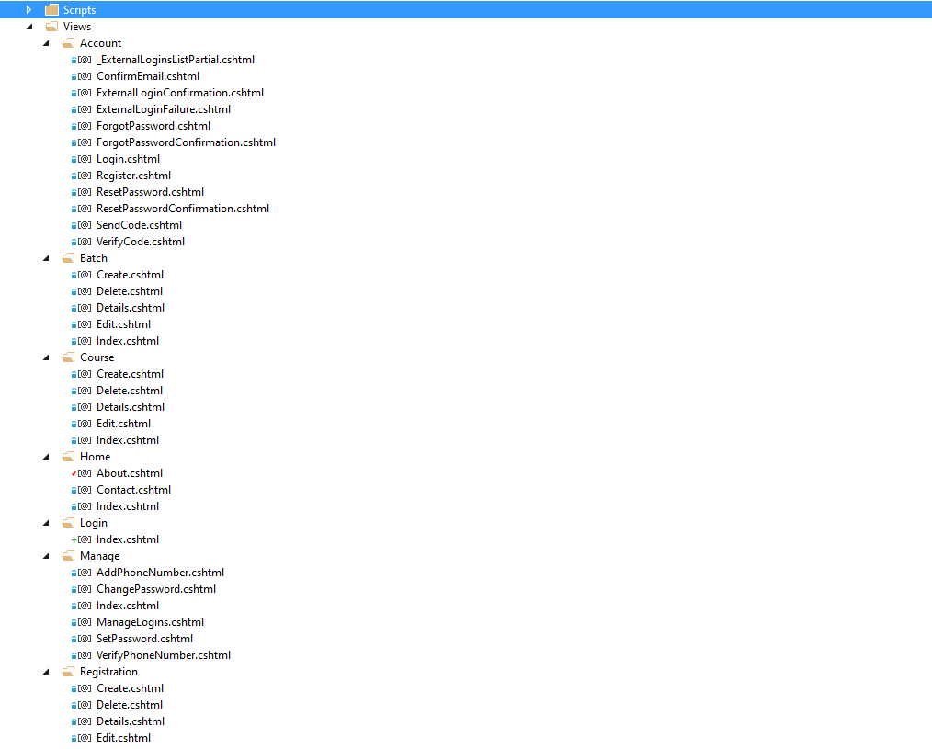

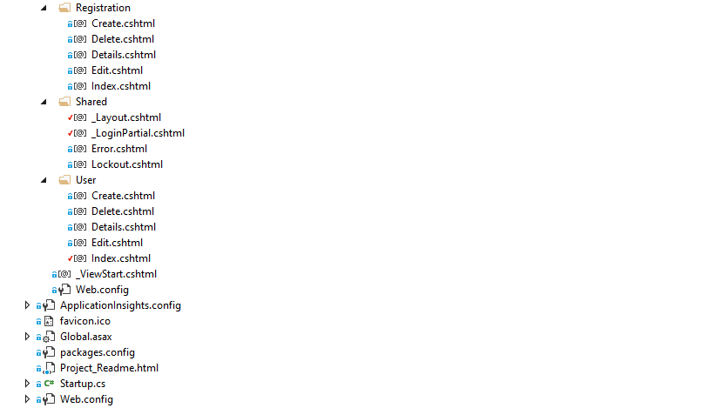

# Conclusion

Student Management System can be used by educational institutions to maintain their student records easily. Achieving this objective is difficult using the manual system as the information is scattered, can be redundant and collecting relevant information may be very time-consuming.

All these problems are solved by this project. This system helps in maintaining the information of pupil of the organization. It can be easily accessed by the manager and kept safe for a long period of time without any changes.

# Link

Project Link ([GitHub](https://github.com/IAMUZAIRMEHMOOD/Software-Design-Architecture-20))